Section 4

Risk Assessment Requirements
Identifying Hazards--- Requirement §201.6(c)(2)(i):
[The risk assessment shall include a] description of the type … of all natural hazards that can affect the jurisdiction.
- Does the plan include a description of the types of all hazards that affect the jurisdiction?
- Does the plan describe the sources used to identify the hazards?
- Does the plan indicate any data limitations?
- Does the plan provide an explanation for eliminating any hazards from consideration?
Profiling Hazard Events---Requirement §201.6(c)(2)(i):
[The risk assessment shall include a] description of the … location and extent of all natural hazards that can affect the jurisdiction. The plan shall include information on previous occurrences of hazard events and on the probability of future hazard events.
- Does the risk assessment identify the location of each hazard being addressed in the plan?
- Does the risk assessment identify the extent of each hazard being addressed in the plan?
- Does the plan provide information on the previous occurrences of each natural hazard?
- Does the risk assessment identify for each hazard, a scale of likelihood of occurrence and the impact?
- Is the location of the natural hazard specifically defined?
- Is the quality of information on the extent above average
- Does the plan document the sources of the information on local, extent, and previous occurrences?
Assessing Vulnerability: Identifying Assets---Requirement §201.6(c)(2) (ii)(A):
[The risk assessment shall include a] description of the jurisdiction’s vulnerability to the hazards described in paragraph (c)(2)(i) of this section. This description shall include an overall summary of each hazard and its impact on the community. The plan should describe vulnerability in terms of:§ The types and numbers of existing and future buildings, infrastructure, and critical facilities located in the identified hazard areas…
- Does the plan include an overall summary description of the jurisdiction vulnerability to the hazards?
- Does the plan address the impacts of the hazards on the community?
- Does the plan provide information on the types and numbers of vulnerable buildings--infrastructures--critical facilities?
- Does the plan address the vulnerability to future buildings, infrastructure, and critical facilities based on current planned development or anticipated areas of growth within the community?
- Does the plan identify the jurisdictions’ repetitive loss areas/structures?
Assessing Vulnerability: Estimating Potential Losses---Requirement §201.6(c)(2) (ii)(B):
[The plan should describe vulnerability in terms of an] estimate of the potential dollar losses to vulnerable structures identified in paragraph (c)(2)(i)(A) of this section and a description of the methodology used to prepare the estimate…
- Does the plan identify vulnerability assets as required in Part 201.6 (c)(ii)(A)?
Assessing Vulnerability: Analyzing Development Trends---Requirement §201.6(c)(2) (ii)(c):
[The plan should describe vulnerability in terms of providing a general description of land uses and development trends within the community so that mitigation options can be considered in future land use decisions.
- Does the plan describe the vulnerability to hazards as required in 201.6(c)(ii)(a)?
- Does the plan indicate the methodology used to prepare the estimate?

Section 4

REGION 5 HAZARD MITIGATION PLAN
pacific lutheran university
Risk ASSESSMENT section

Table of Contents
Risk Assessment Requirements 1
Table of Contents 2
Section Overview 3
Table 4-1a WA Region 5 Hazard Identification Summary – Geological 4
Table 4-1b WA Region 5 Hazard Identification Summary – Meteorological 6
Table 4-2 Vulnerability Analysis: General Exposure 11
Table 4-3 Vulnerability Analysis: Population Exposure 11
Table 4-4 Vulnerability Analysis: General Infrastructure Exposure 12
Table 4-5a Consequence Analysis Chart – Geological, 13
Table 4-5b Consequence Analysis Chart – Meteorological 14
ENDNOTES 16

Section Overview
The Risk Assessment portrays the threats of natural hazards, the vulnerabilities of a jurisdiction to the hazards, and the consequences of hazards impacting communities. Each hazard is addressed as a threat and is identified and profiled in the Hazard Identification. The vulnerabilities to and consequences of a given hazard are addressed in the Vulnerability Analysis. Vulnerability is analyzed in terms of exposure of both population and infrastructure to each hazard. Consequences are identified as anticipated, predicted, or documented impacts caused by a given hazard when considering the vulnerability analysis and the characteristics of the hazard as outlined in its identification.

RISK

Threat

Vulnerability

Consequence

The WA Region 5 Hazard Identification was used for this plan. Each jurisdiction’s Vulnerability and Consequence Analysis are based on the Region 5 Hazard Identification. The Region 5 Hazard Identification can be found in the Base Plan. Each hazard is identified in subsections. The subsections are grouped by hazard-type (i.e., geological and meteorological hazards) and then alphabetically within each type. A summary table of the WA Region 5 Hazard Identification is included in this section as Table 4-1a and Table 4-1b.

The Vulnerability Analysis is displayed in five tables:

- Table 4-2 General Exposure
- Table 4-3 Population Exposure
- Table 4-4 General Infrastructure Exposure
- Table 4-5a Consequence Analysis Chart – Geological
- Table 4-5b Consequence Analysis Chart – Meteorological

Each jurisdiction has its own Vulnerability Analysis, and it is included in this section.

The Consequence Identification is organized by Threat. Each threat page summarizes the hazard, graphically illustrates exposures from the Vulnerability Analysis, and lists corresponding Consequences. Each jurisdiction has its own Consequence Identification and it is included in this section: avalanche, earthquake, landslide, tsunami, volcanic, drought, flood, severe weather, and wildland/urban interface fire.

Specific information and analysis of a jurisdiction’s owned (public) infrastructure is addressed in the Infrastructure Section of its Plan.
(This page intentionally left blank)

Table 4-1a WA Region 5 Hazard Identification Summary – Geological
THREAT |  | Declaration # Date/Place | Probability/Recurrence | Maps, Figures and TAbles
Geological | AVALANCHE | Not Applicable | Yearly in the mountainous areas of the County including Mt. Rainier National Park and the Cascades. | Slab Avalanche  Areas Vulnerable to Avalanche  Pierce County Avalanches of Record
Geological | Earthquake | N/A--7/22/2001 Nisqually Delta  N/A--6/10/2001 Satsop  DR-1361-WA--2/2001 Nisqually  N/A--7/2/1999 Satsop  N/A--4/29/1965 Maury Island, South Puget Sound  N/A--4/13/1949 South Puget Sound  N/A--2/14/1946 Maury Island | Magnitude 4.3  Magnitude 5.0—Intraplate Earthquake  Magnitude 6.8—Intraplate Earthquake  Magnitude 5.8—Intraplate Earthquake  Magnitude 6.5—Intraplate Earthquake  Magnitude 7.0—Intraplate Earthquake  Magnitude 6.3  40 years or less occurrence  Historical Record—About every 23 years for intraplate earthquakes | Types of Earthquakes  Major Faults in the Puget Sound Basin  Seattle and Tacoma Fault Segments  Pierce County Seismic Hazard  Major Pacific Northwest Earthquakes  Notable Earthquakes Felt in Pierce County  Salmon Beach, Tacoma Washington following Feb 2001 Earthquake  Liquefaction Niigata Japan-1964  Lateral Spreading – March 2001
Geological | Landslide | DR-1159-WA--12/96-2/1997  DR-852-WA--1/1990  DR-545-WA--12/1977 | Slides with minor impact (damage to 5 or less developed properties or $1,000,000 or less damage) 10 years or less. Slides with significant impact (damage to 6 or more developed properties or $1,000,000 or greater damage) 100 years or less. | Northeast Tacoma Landslide 01/2007  Pierce County Landslide and Soil Erosion Hazard  Pierce County Shoreline Slope Stability Areas  Notable Landslides in Pierce County  Ski Park Road – Landslide 01/31/03  SR-165 Bridge Along Carbon River – Landslide 2/1996  Aldercrest Drive - Landslide
Geological | Tsunami | N/A--1894 Puyallup River Delta  N/A--1943 Puyallup River Delta (did not induce tsunami)  N/A--1949 Tacoma Narrows | Due to the limited historic record, until further research can provide a better estimate a recurrence rate of 100 years plus or minus will be used. | Hawaii 1957 – Residents Explore Ocean Floor Before Tsunami  Hawaii 1949 – Wave Overtakes a Seawall  Puget Sound Fault Zone Locations, Vertical Deformation and Peak Ground Acceleration  Seattle and Tacoma Faults  Tsunami Inundation and Current Based on Earthquake Scenario  Puget Sound Landslide Areas and Corresponding Tsunamis  Puget Sound River Deltas, Tsunami Evidence and Peak Ground Acceleration  Salmon Beach, Pierce County 1949 – Tsunamigenic Subaerial Landslide  Puyallup River Delta – Submarine Landslides  Puyallup River Delta – Submarine Landslides and Scarp  Damage in Tacoma from 1894 Tsunami
Geological | Volcanic | DR-623-WA--5/1980 | The recurrence rate for either a major lahar (Case I or Case II) or a major tephra eruption is 500 to 1000 years. | Volcano Hazards  Debris Flow at Tahoma Creek – July 26, 1988  Douglas Fir Stump – Electron Lahar Deposit in Orting  Landslide from Little Tahoma Peak Covering Emmons Glacier  Tephra Types and Sizes  Lahars, Lava Flows and Pyroclastic Hazards of Mt. Rainier  Estimated Lahar Travel Times for Lahars 10₇ to 10₈ Cubic Meters in Volume  Ashfall Probability from Mt. Rainier  Annual Probability of 10 Centimeters or more of Tephra Accumulation in the Pacific NW  Cascade Eruptions  Mt. Rainier Identified Tephra, last 10,000 years  Pierce County River Valley Debris Flow History
Table 4- b WA Region 5 Hazard Identification Summary – Meteorological
Hazard |  | Declaration # Date/Place |  | Probability/Recurrence | Maps, FIGURES and tables
Meteorological | CLIMATE CHANGE | Not Applicable |  | Not Applicable | Global Temperature Change: 1850 to 2006  Recent and Projected Temperatures for the Pacific Northwest  Comparison of the South Cascade Glacier: 1928 to 2003  Lower Nisqually Glacier Retreat: 1912 to 2001
Meteorological | DROUGHT | DR-981-WA--1/1993  DR-137-WA--10/1962 |  | 50 years or less occurrence | Sequence of Drought Impacts  Palmer Drought Severity Index  Pierce County Watersheds  %Area of Basin in Drought Conditions Since 1895  %Time in Severe to Extreme Drought: 1895-1995  %Time in Severe to Extreme Drought: 1985-1995  Notable Droughts Affecting Pierce County  Columbia River Basin  USDA Climate Zones – Washington State
Meteorological | Flood | DR-1671-WA--11/2006  DR-1499-WA--10/2003  DR-1159-WA--12/96-2/1997  DR-1100-WA--1-2/1996  DR-1079-WA--11-12/1995  DR-896-WA--12/1990  DR-883-WA--11/1990 | DR-852-WA--1/1990  DR-784-WA--11/1986  DR-545-WA--12/1977  DR-492-WA--12/1975  DR-328-WA--2/1972  DR-185-WA--12/1964 | 5 years or less occurrence  Best Available Science--The frequency of the repetitive loss claims indicates there is approximately a 33 percent chance of flooding occurring each year. | Pierce County Watersheds  Pierce County Flood Hazard  Pierce County Repetitive Loss Areas  Clear Creek Basin  Repetitive Flood Loss Aerial Photo  Flood Hazard Declared Disasters  Feb 8, 1996 Flooding – Del Rio Mobile Homes Along Puyallup River  Nov 2006 Flooding River Park Estates – Along Puyallup River  Nov 2006 Flooding State Route 410 – Along Puyallup River  Nov 2006 Flooding Rainier Manor – Along Puyallup River
Meteorological | Since 1978 3 Repetitive Loss Areas have produced 83 Claims totaling Nearly $1.78 Millions Dollars.
Meteorological | Severe WeATHER | DR-1682-WA--12/2006  DR-1671-WA--11/2006  DR-1159-WA--12/96-2/1997  DR-1152-WA--11/19/1996 | DR-981-WA--1/1993  DR-137-WA--10/1962 | The recurrence rate for all types of severe storms is 5 years or less. | Fujita Tornado Damage Scale  Windstorm Tracks  Pierce County Severe Weather Wind Hazard – South Wind Event  Pierce County Severe Weather Wind Hazard – East Wind Event  Notable Severe Weather in Pierce County  Snowstorm 01/2004 Downtown Tacoma  Satellite Image – Hanukkah Eve Windstorm  Before/After Tornado Damage Greensburg KS 05/04/07  Public Works Responds 2005 Snowstorm  Downed Power Pole 02/2006 Windstorm  County Road December 2006 Windstorm  Tacoma Narrows Bridge – November 7, 1940 Windstorm
Meteorological | WUI Fire | Not Applicable |  | Based on information from WA DNR the probability of recurrence for WUI fire hazard to Pierce County is 5 years or less. | Washington State Fire Hazard Map  Pierce County Forest Canopy  Industrial Fire Precaution Level Shutdown Zones  Carbon Copy Fire August 2006  Washington State DNR Wildland Fire Statistics: 1973-2007  DNR Wildland Response South Puget Sound Region: 2002-2007  Pierce County DNR Fires

Map 4- Pacific Lutheran University Flood Hazard Map
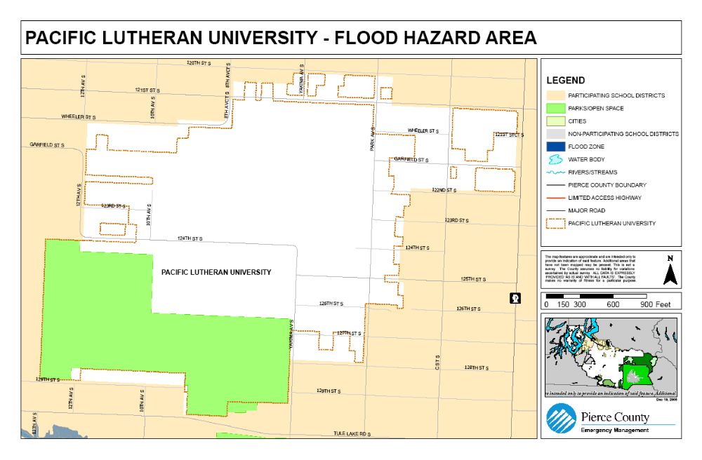
Map 4- Pacific Lutheran University Lahar Hazard Map
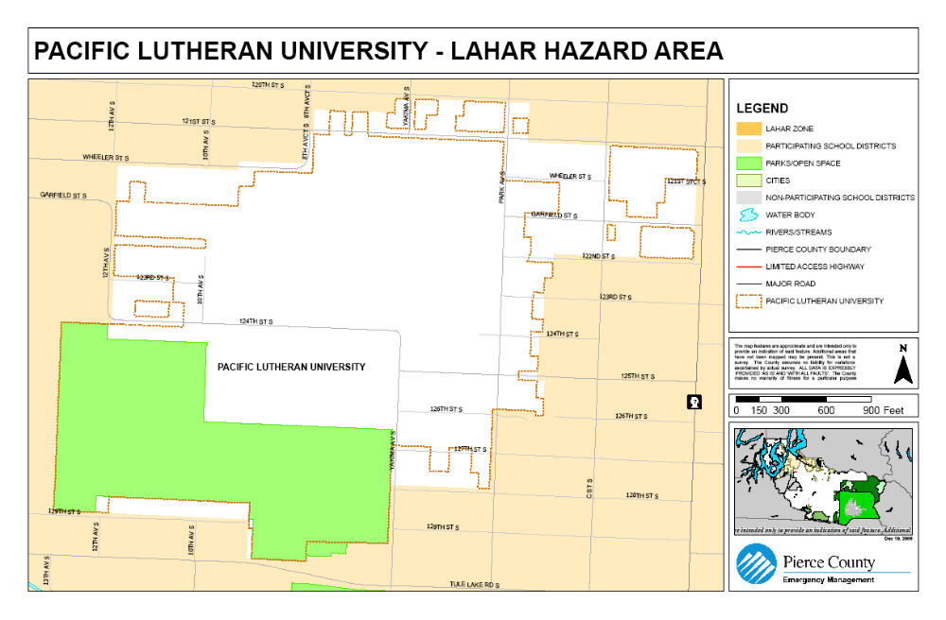
Map 4- Pacific Lutheran University Landslide Hazard Map
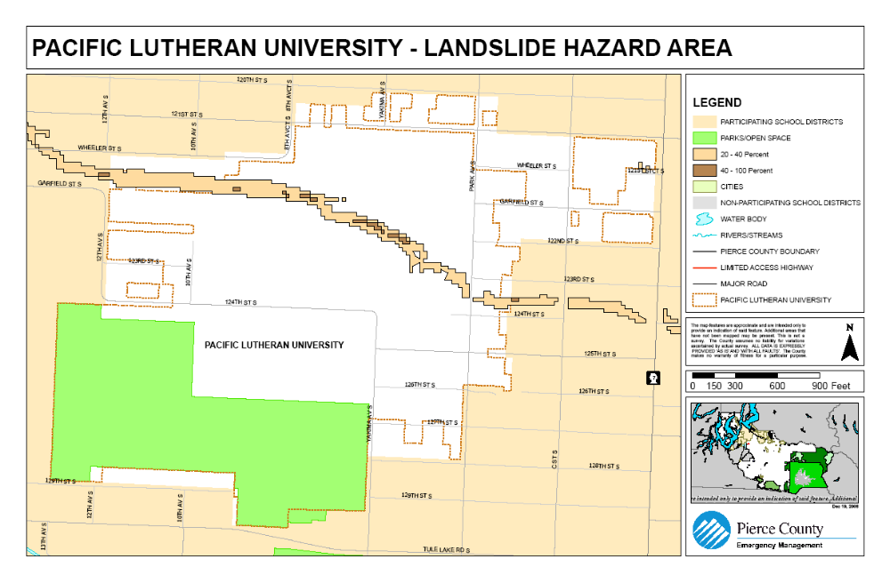
Map 4- Pacific Lutheran University Seismic Hazard Map
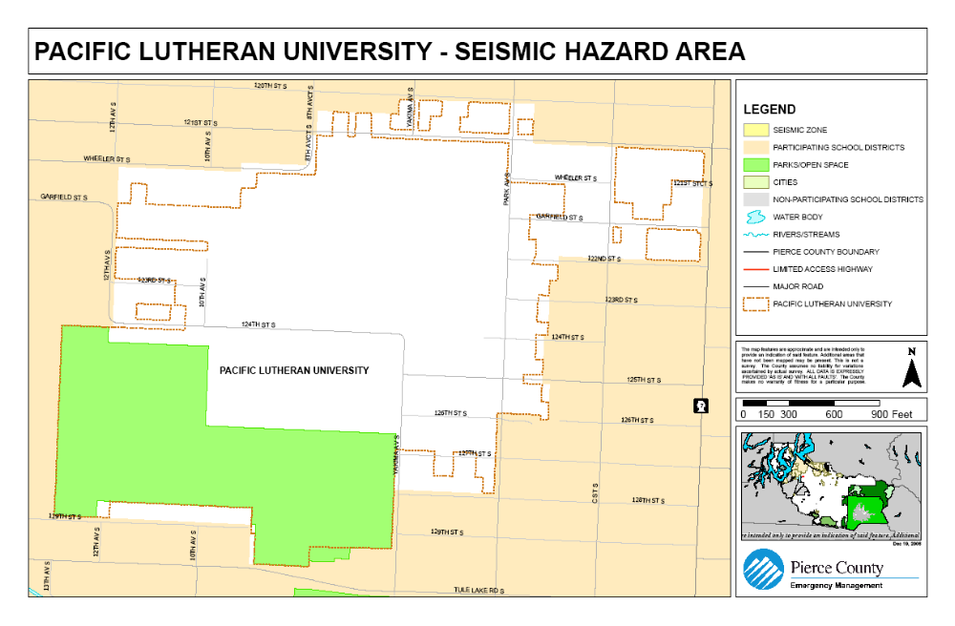
Table 4- 2 Vulnerability Analysis: General Exposure
Threat |  | Area (sq mi) |  | Parcels
 |  | Total | % Base | Total | % Base
BASE |  | .26 | 100% | 249 | 100%
Geological | Avalanche | NA | NA | NA | NA
Geological | Earthquake | 0 | 0 | 0 | 0
Geological | Landslide | .03 | 12% | 23 | 9%
Geological | Tsunami | NA | NA | NA | NA
Geological | Volcanic | 0 | 0 | 0 | 0
Meteorological | Drought | .26 | 100% | 249 | 100%
Meteorological | Flood | 0 | 0 | 0 | 0
Meteorological | Severe Weather | .26 | 100% | 249 | 100%
Meteorological | WUI Fire | 0 | 0 | 0 | 0

Table 4- 3 Vulnerability Analysis: Population Exposure
Threat |  | Population |  |  |  | Special Populations  (of total Exposed Population)
 |  | Total | % Base | Density (pop/sq mi) |  | 65+ yrs |  |  | 18- yrs
 |  |  |  |  |  | # |  | % | # | %
BASE |  | 1,755 | 100% |  | 6,750 |  | 63 | 4% | 53 | 3%
Geological | Avalanche | NA | NA |  | NA |  | NA | NA | NA | NA
Geological | Earthquake | 0 | 0 |  | 0 |  | 0 | 0 | 0 | 0
Geological | Landslide | 84 | 5% |  | 2,532 |  | 14 | 17% | 8 | 10%
Geological | Tsunami | NA | NA |  | NA |  | NA | NA | NA | NA
Geological | Volcanic | 0 | 0 |  | 0 |  | 0 | 0 | 0 | 0
Meteorological | Drought | 1,755 | 100% |  | 6,750 |  | 63 | 4% | 53 | 3%
Meteorological | Flood | 0 | 0 |  | 0 |  | 0 | 0 | 0 | 0
Meteorological | Severe Weather | 1,755 | 100% |  | 6,750 |  | 63 | 4% | 53 | 3%
Meteorological | WUI Fire | 0 | 0 |  | 0 |  | 0 | 0 | 0 | 0

Table 4- 4 Vulnerability Analysis: General Infrastructure Exposure
Threat |  | land value |  |  |  | improveD value |  |  | total assessed value
 |  | Total ($) | % Base | Avg. Value ($) |  | Total ($) | % Base | Avg. Value ($) | Total ($) | % Base | Avg. Value ($)
BASE |  | 36,213,400 | 100% |  | 145,435 | 107,700,400 | 100% | 432,532 | 143,913,800 | 100% | 577,967
Geological | Avalanche | NA | NA |  | NA | NA | NA | NA | NA | NA | NA
Geological | Earthquake | 0 | 0 |  | 0 | 0 | 0 | 0 | 0 | 0 | 0
Geological | Landslide | 4,914,000 | 14$ |  | 213,652 | 24,238,300 | 23% | 1,053,839 | 29,152,300 | 20% | 1,267,491
Geological | Tsunami | NA | NA |  | NA | NA | NA | NA | NA | NA | NA
Geological | Volcanic | 0 | 0 |  | 0 | 0 | 0 | 0 | 0 | 0 | 0
Meteorological | Drought | 38,167,800 | 100% |  | 136,313 | 89,009,600 | 100% | 317,891 | 127,177,400 | 100% | 454,205
Meteorological | Flood | 0 | 0 |  | 0 | 0 | 0 | 0 | 0 | 0 | 0
Meteorological | Severe Weather | 38,167,800 | 100% |  | 136,313 | 89,009,600 | 100% | 317,891 | 127,177,400 | 100% | 454,205
Meteorological | WUI Fire | 0 | 0 |  | 0 | 0 | 0 | 0 | 0 | 0 | 0

Table 4-5a Consequence Analysis Chart – Geological,
Threat |  | CONSEQUENCE | YES OR NO
Geological | Avalanche | Impact to the Public | No
Geological | Avalanche | Impact to the Responders | No
Geological | Avalanche | Impact to COG and/or COOP in the Jurisdiction | No
Geological | Avalanche | Impact to Property, Facilities and Infrastructure | No
Geological | Avalanche | Impact to the Environment | No
Geological | Avalanche | Impact to the Jurisdiction Economic Condition | No
Geological | Avalanche | Impact to Reputation or Confidence in Jurisdiction | No
Geological | Earthquake | Impact to the Public | Yes
Geological | Earthquake | Impact to the Responders | Yes
Geological | Earthquake | Impact to COG and/or COOP in the Jurisdiction | Yes
Geological | Earthquake | Impact to Property, Facilities and Infrastructure | Yes
Geological | Earthquake | Impact to the Environment | Yes
Geological | Earthquake | Impact to the Jurisdiction Economic Condition | Yes
Geological | Earthquake | Impact to Reputation or Confidence in Jurisdiction | Yes
Geological | Landslide | Impact to the Public | Yes
Geological | Landslide | Impact to the Responders | No
Geological | Landslide | Impact to COG and/or COOP in the Jurisdiction | No
Geological | Landslide | Impact to Property, Facilities and Infrastructure | Yes
Geological | Landslide | Impact to the Environment | No
Geological | Landslide | Impact to the Jurisdiction Economic Condition | Yes
Geological | Landslide | Impact to Reputation or Confidence in Jurisdiction | Yes
Geological | Tsunami | Impact to the Public | No
Geological | Tsunami | Impact to the Responders | No
Geological | Tsunami | Impact to COG and/or COOP in the Jurisdiction | No
Geological | Tsunami | Impact to Property, Facilities and Infrastructure | No
Geological | Tsunami | Impact to the Environment | No
Geological | Tsunami | Impact to the Jurisdiction Economic Condition | No
Geological | Tsunami | Impact to Reputation or Confidence in Jurisdiction | No
Geological | Volcanic | Impact to the Public | Yes
Geological | Volcanic | Impact to the Responders | Yes
Geological | Volcanic | Impact to COG and/or COOP in the Jurisdiction | No
Geological | Volcanic | Impact to Property, Facilities and Infrastructure | Yes
Geological | Volcanic | Impact to the Environment | Yes
Geological | Volcanic | Impact to the Jurisdiction Economic Condition | Yes
Geological | Volcanic | Impact to Reputation or Confidence in Jurisdiction | Yes
Table 4-5b Consequence Analysis Chart – Meteorological
Threat |  | CONSEQUENCE | YES OR NO
Meteorological | Drought | Impact to the Public | Yes
Meteorological | Drought | Impact to the Responders | No
Meteorological | Drought | Impact to COG and/or COOP in the Jurisdiction | No
Meteorological | Drought | Impact to Property, Facilities and Infrastructure | No
Meteorological | Drought | Impact to the Environment | Yes
Meteorological | Drought | Impact to the Jurisdiction Economic Condition | No
Meteorological | Drought | Impact to Reputation or Confidence in Jurisdiction | No
Meteorological | Flood | Impact to the Public | No
Meteorological | Flood | Impact to the Responders | No
Meteorological | Flood | Impact to COG and/or COOP in the Jurisdiction | No
Meteorological | Flood | Impact to Property, Facilities and Infrastructure | No
Meteorological | Flood | Impact to the Environment | No
Meteorological | Flood | Impact to the Jurisdiction Economic Condition | No
Meteorological | Flood | Impact to Reputation or Confidence in Jurisdiction | No
Meteorological | Severe Weather | Impact to the Public | Yes
Meteorological | Severe Weather | Impact to the Responders | Yes
Meteorological | Severe Weather | Impact to COG and/or COOP in the Jurisdiction | Yes
Meteorological | Severe Weather | Impact to Property, Facilities and Infrastructure | Yes
Meteorological | Severe Weather | Impact to the Environment | Yes
Meteorological | Severe Weather | Impact to the Jurisdiction Economic Condition | Yes
Meteorological | Severe Weather | Impact to Reputation or Confidence in Jurisdiction | Yes
Meteorological | WUI Fire | Impact to the Public | No
Meteorological | WUI Fire | Impact to the Responders | No
Meteorological | WUI Fire | Impact to COG and/or COOP in the Jurisdiction | No
Meteorological | WUI Fire | Impact to Property, Facilities and Infrastructure | No
Meteorological | WUI Fire | Impact to the Environment | No
Meteorological | WUI Fire | Impact to the Jurisdiction Economic Condition | No
Meteorological | WUI Fire | Impact to Reputation or Confidence in Jurisdiction | No

(This page intentionally left blank)

Endnotes

Jurisdiction is not vulnerable to this hazard, therefore it is marked NA or non-applicable.
It should be noted here that although all residents, all property and all infrastructure of Pacific Lutheran University are vulnerable to earthquake shaking, not all are subject to the affects of liquefaction and liquefiable soils which is what is represented here.
Jurisdiction is not vulnerable to this hazard, therefore it is marked NA or non-applicable.
The threat of volcanic ash fall affects the entire Region 5, however some jurisdictions are specifically threatened by lahar flows directly from Mt. Rainier; an active volcano.
The entire jurisdiction is vulnerable to drought. There are three things that must be understood about the affect of drought on the jurisdiction: 1) Drought is a Region wide event. When it does affect Pierce County, it will affect every jurisdiction, 2) Drought will gradually develop over time. It is a gradually escalating emergency that may take from months to years to affect the jurisdiction. Initially lack of water may not even be noticed by the citizens. However, as the drought continues, its effects will be noticed by a continually expanding portion of the community until it is felt by all, and 3) Jurisdictions will be affected differently at different times as a drought develops. This will vary depending on the needs of the each local jurisdiction. Some examples are: jurisdictions that have industry that requires a continuous supply of a large quantity of water; others have agriculture that requires water, but may only require it at certain times of the year; and, some jurisdictions have a backup source of water while others do not.
Pacific Lutheran University, while having a few trees on campus is not considered a wildland/urban interface threat.
Population in this case is from the Census 2000 from the Office of Financial Management. These numbers are used instead of those provided by the University because of the number of calculations that are available from the Census 2000 numbers and not available from the University numbers.
In the Impact to Property, Facilities and Infrastructure, both Tables 4-5a and 4-5b, look at the impact to all property, facilities and infrastructure existing in the jurisdiction, not just to that owned by the jurisdiction.
The consideration for each of these hazards, in both Tables 4-5a and 4-5b, as to whether an individual hazard’s consequences exist, or not, is based on a possible worst case scenario. It must also be understood that a “yes” means that there is a good possibility that the consequence it refers to could happen as a result of the hazard, not that it will. Conversely “No” means that it is highly unlikely that that consequence will have a major impact, not that there will be no impact at all.
While the major volcanic hazard from Mt. Rainier is from a lahar descending the main river valleys surrounding the mountain, it is not the only problem. Most jurisdictions could receive tephra in greater or lesser amounts, sometimes with damaging results. Consequence analyses in this section take into account the possibility of tephra deposition in addition to a lahar.

