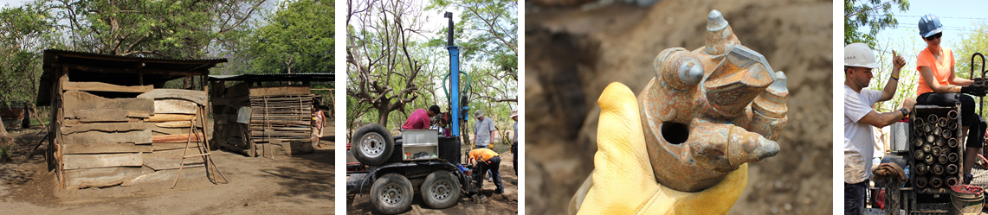
APPLICATION PACKET

PLU Well Installation Course in Nicaragua
TAP IN: HOW NONPROFITS AND SOCIAL BUSINESSES IMPACT THE WORLD
Course: Spring Semester – February through May, 2016
In Country Experience: June 4-11, 2016

Full Name: ____________________________________________________________
PLU Student ID#:________________________________
Academic Standing (year in school):_____________________________
Major(s): _______________________________ _______________________________
Minor(s): _______________________________ _______________________________
Email:__________________________________ Phone:__________________________
Do you anticipate taking this course for internship credits (up to 4 credits)? __Yes! __ Likely __ No
Do you have a valid passport? __Yes (Expiration date:___/___) __No __In Process
Have you read the FAQ’s (www.plu.edu/busa/nicaragua)? __Yes __No

INSTRUCTIONS: Please complete this document in MS Word and submit either a .docx file or a .pdf file of the completed application to: Becki Torgerson (torgerrm@plu.edu). Applications are due by 10/15/2015, though consistent with the Wang Center policies, the course will be closed when 15 applications are received, which may be before 10/15/2015. For that reason, you are encouraged to submit your application as quickly as possible.

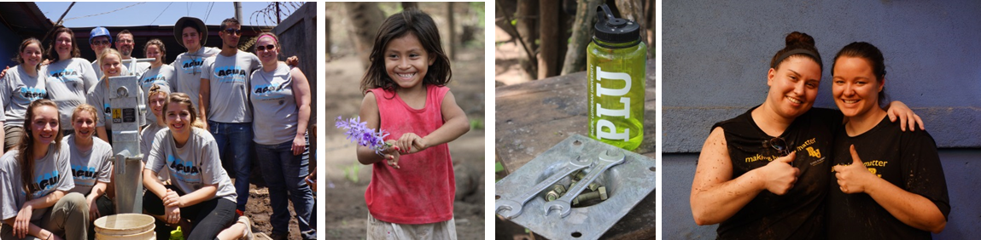

SHORT ANSWER QUESTIONS
Please complete the application and type your answers after each question. Answers to most questions should include at least an insightful paragraph.

- Please thoughtfully describe the reason you are interested in this study away program.

- Please explain any links between this study away program and (1) your academic area of study and then, (2) your future career interests.

- Do you have any experience in global travel or global service projects? Local service projects? Describe.

- We will be serving in the poorest country in Central America, and will likely be serving in a village area without water, electricity, or traditional restrooms. Our team will be interacting with members of a village as we build relationships and provide education and encouragement. Please briefly answer the following…
How will you build relationships in this global setting?
How will you show love in this global setting?
Do you have any concerns about this global setting?

- First, read the FAQ’s (www.plu.edu/busa/nicaragua) regarding our non-profit partner. Next, note that we will be partnering with a faith inspired nonprofit to drill the well and to provide hygiene training. Similar to what happens at PLU events, there may be prayers involved to ask for blessings for the work, the village community, and the well. Further, nonprofit staff, other PLU participants and perhaps even residents of the village area may integrate conversation around their faith and their experiences while in Nicaragua. Participants do not have to have a faith to participate in this study away program, though should be aware of this and should be comfortable working in this environment. Please explain how you would envision working alongside a faith inspired nonprofit.

- Do you have any special skills related to this study away opportunity (e.g., fluent in Spanish, experience with hygiene education, incredible soccer skills for Team PLU, etc.)?

- Write a brief autobiographical sketch as if you were writing a letter introducing yourself to the nonprofit team with whom we will work in Nicaragua. How would you describe yourself? What role, personality, and strengths do you bring to a group? What challenges do groups present to you?

- An opportunity for internship credit exists with this project, allowing an internship experience in nonprofit marketing/fundraising alongside with the field experience in Nicaragua. This could count for the School of Business internship credits or for the nonprofit leadership minor (NPLM) required internship. Knowing that preference may go to those who utilize this for internship credit, would you be interested in an internship related to this project in Nicaragua? (This can be a short answer. If yes, please explain)

You are required to have one faculty member write a letter of recommendation on your behalf. You are encouraged to have two faculty members write a recommendation, as one may be delayed and any final decisions for participation must include a recommendation. Which faculty members will you ask to submit a recommendation for you (helps us with tracking)? Please forward this recommendation directly to faculty.

Name:____________________________________ Dept:__________________ Email:___________________

Name:____________________________________ Dept:__________________ Email:___________________
Note: Please download the Recommendation Form and send directly to your Faculty member.

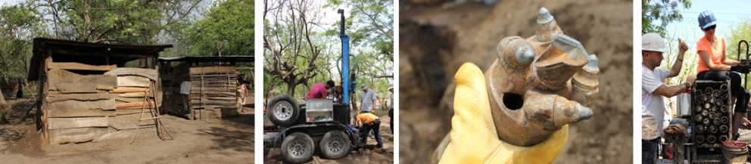

FACULTY RECOMMENDATION FOR NicarAGUA Course
(Using a faculty member in your major is preferred if possible)
- To the Student Applicant:

BUSA 485-Nicaragua / Prof. Mark Mulder
Name (please print) Off-Campus Course Course Professor

Your signature is required to authorize the professor listed below to provide a recommendation on your behalf. After completing Section A, give this form to a professor who knows you well.
I hereby authorize to complete this form.
(name of faculty member)
Under the provision of the Family Education Rights and Privacy Act of 1974, I waive my right of access to this recommendation and understand that the information provided will be used only for the purpose for which it was prepared.
Yes No

Student signature

B. To Faculty: The individual named above has applied for an off-campus program which will include the installation of a well to bring clean water to a village in Nicaragua. We would appreciate your careful assessment of this individual’s intellectual ability and motivation, past performance, maturity, and his or her potential for successfully adjusting to life and study in a foreign country. Your assessment will be reviewed by the course faculty leader and is a very important part of the application process. Please be frank with your comments. Thank you!

How long have you known the applicant and in what capacity? _________________________________________
Would you be comfortable traveling with this student? ________________________________________________

Academic Ability

Excellent Good Average Below Average Unknown
Ability to learn factual information
Applies concepts to new situations
Ability to learn independently
Can assess information based on
different perspectives
Additional comments on academic ability:

Motivation

Excellent Good Average Below Average Unknown
Seriousness of purpose
Interest in other cultures
Intellectual curiosity
Additional comments on motivation:

Responsibility

Excellent Good Average Below Average Unknown
Carries work to completion
Uses good judgment
Reaction to stress
Ability to work without supervision
Takes direction well
Additional comments on responsibility:

Relating to Others

Excellent Good Average Below Average Unknown
Sensitivity to diversity
Caring, kind and friendly
Works well with others
Adjusts well to new situations
Additional comments on relating to others:

How do you recommend this student for a well project course in Nicaragua?
_____ Without reservation _____ With Reservation _____ Not Recommended

Among all students you have taught, how would you rate this applicant on a combined measure of academic performance and personal promise?
_____ Top 10% _____ Upper 25% _____ Upper 50% _____ Lower 50%

Your honest assessment of this student and any comments are extremely important to the faculty leader of this course. Please feel free to add any other information or opinions that you feel would be useful or important to know about the applicant.

___________________________________________________________________________________

___________________________________________________________________________________

___________________________________________________________________________________

Name (please print)

Signature Date

Position or Title Department

Upon completion, please forward to the School of Business by mail or email
attn: Becki Torgerson (torgerrm@plu.edu), (253) 535-7245
Pacific Lutheran University, School of Business
Tacoma, WA 98447

