Paymentnet 4 Tutorial:

**Change account codes, split transactions and set query to view 45 days of charges.**

**How to change accounting codes on a transaction:**

Select the charge from the Transaction List.

On the Transaction Detail screen, select the Accounting code to change. *If drop-down list does not appear see below for settings.

If the code does not appear in the drop-down list (only the first 100 codes appear), delete the number in the box and begin typing the new code, an updated drop-down list will appear, select the code from the list then enter.

Click the save button and wait for a green check mark to appear on the right of the screen.

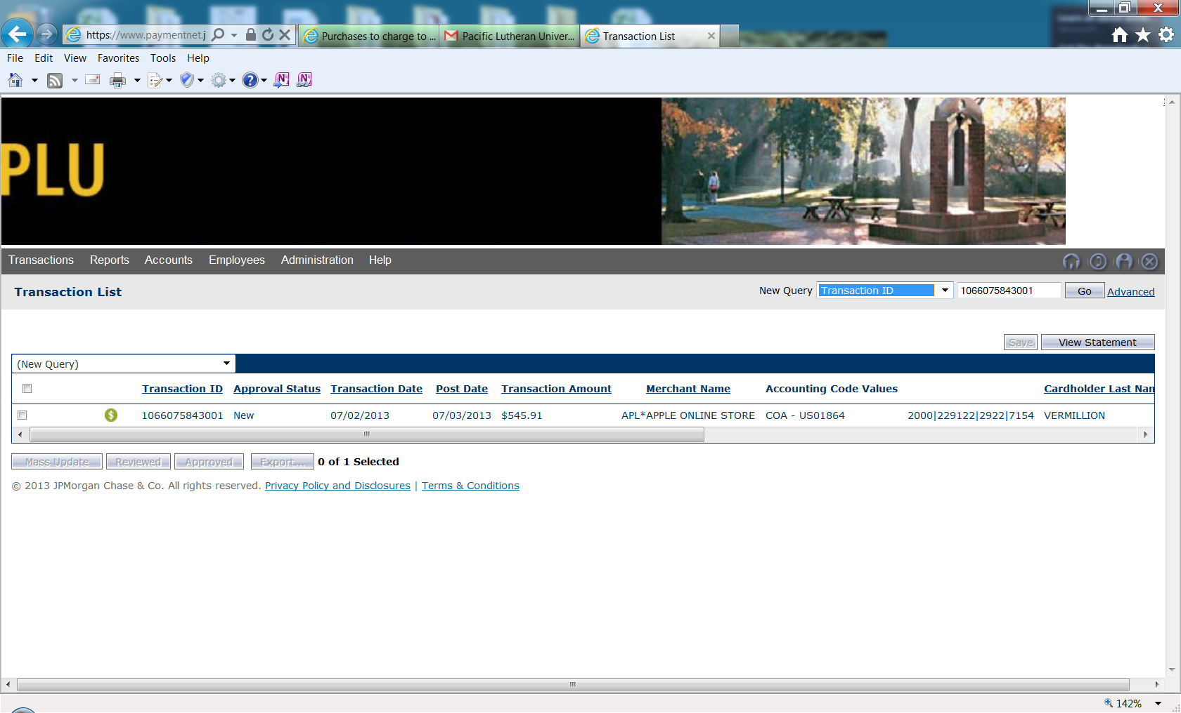

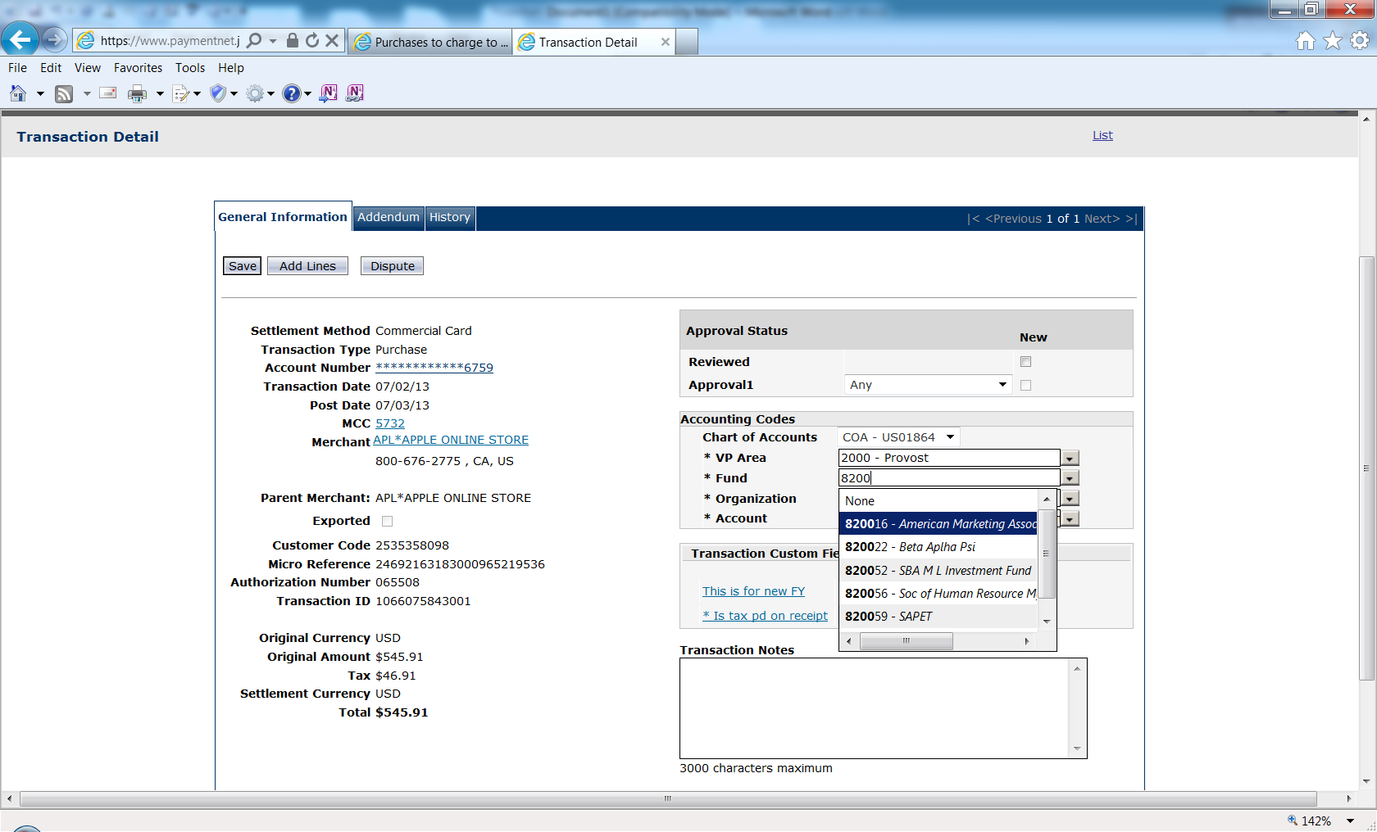

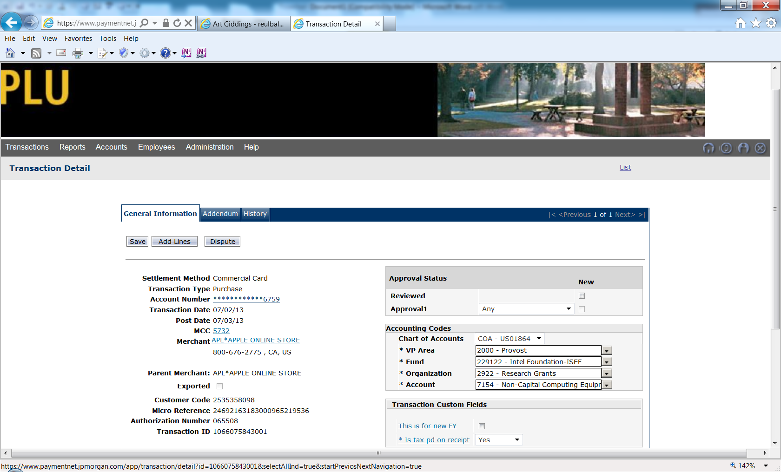

**Split transactions to different fund, org, and account codes:**

Select the charge from the Transactions List to access the Transaction Detail screen.

Select the Add Lines button

Enter the number of splits in the available field.

Click the Add button.

Scroll down to bottom of the screen and a new area will appear. Check Line Item Level Accounting

Select the icon that looks like a sideways triangle and the Accounting Codes for the split will appear.

Adjust the split by unit price or as a percent of the total. Remember the unit price /percent must equal the original amount. Save.

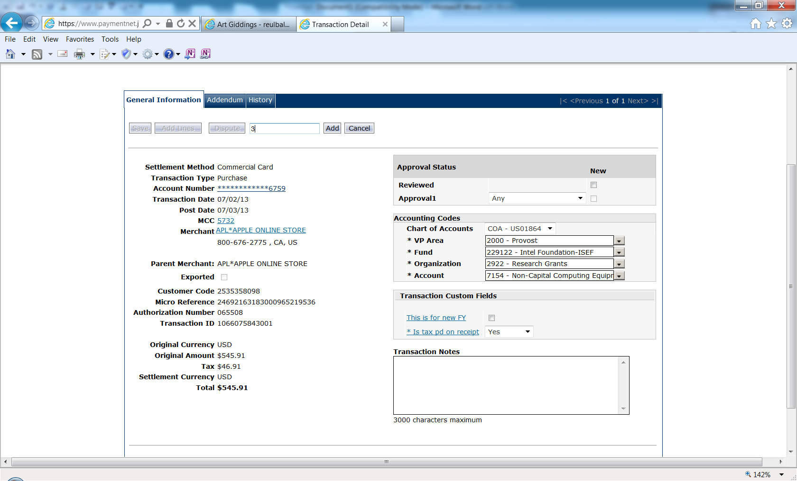

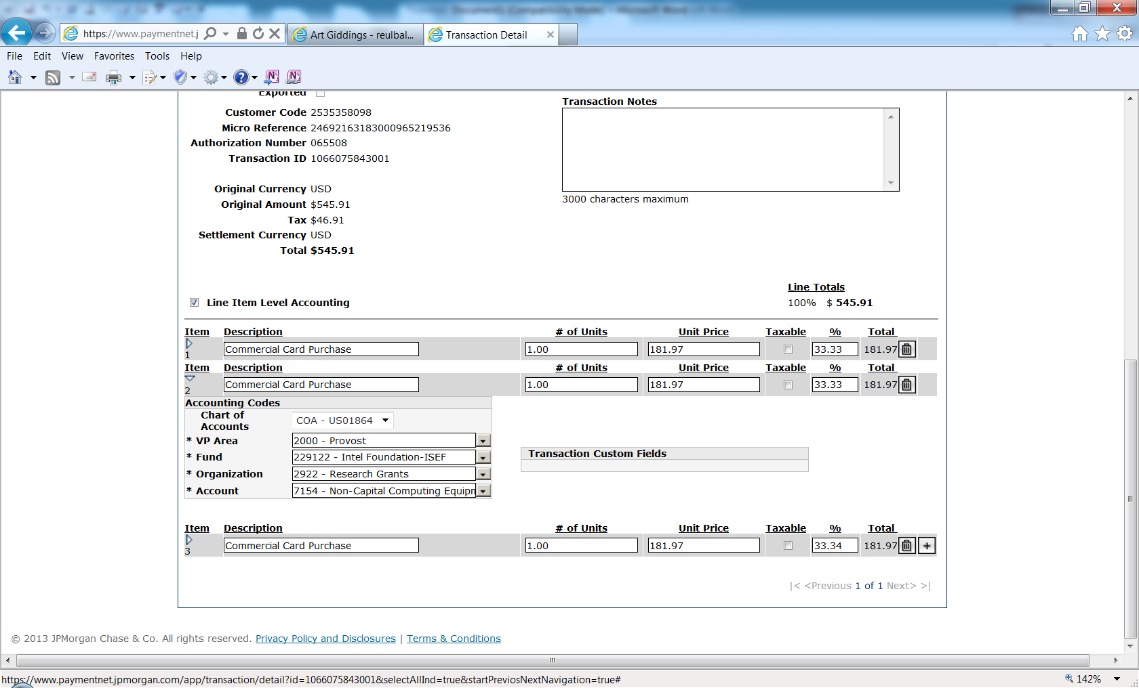

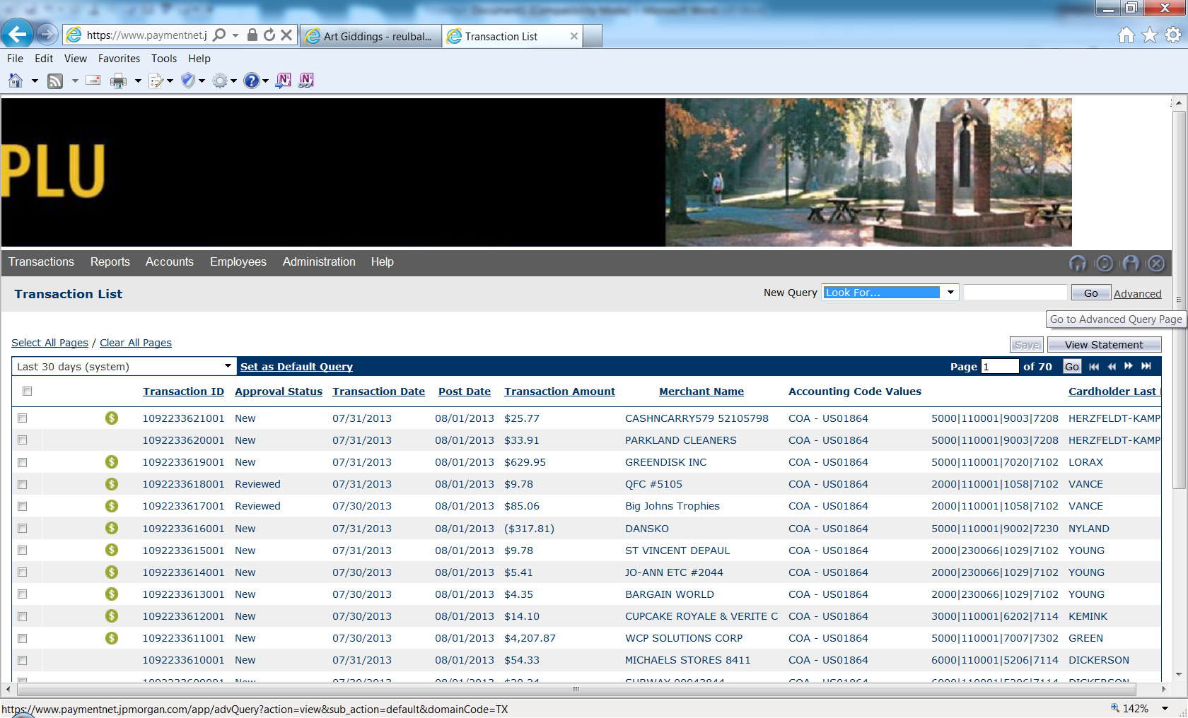

**Set up view of transactions greater than 30 days:**

Select Transaction List, then Manage in the drop-down box.

Click the Advanced button to the far right of the screen next to the Go button.

Under Date Range change the value from 30 days to 45 days. This will allow you to view 45 days of transactions on your Transaction list.

Click the trash can   
to delete this line.

Click Process.

Click Save Query.

Name the Query and select Save.

Select as Set as Default Query to allow for all 45 days of charges to appear each time you access the Transaction page.

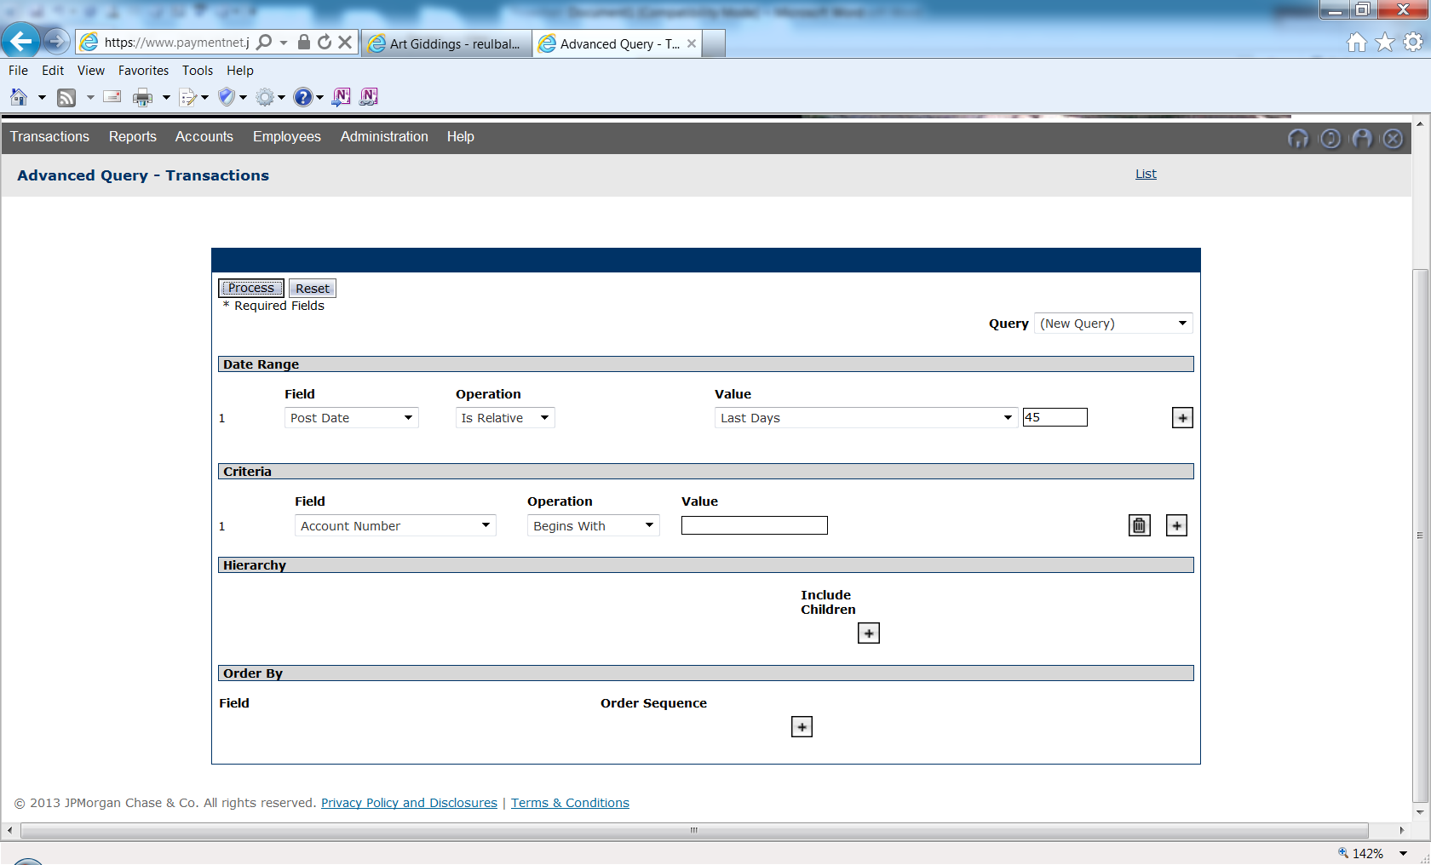

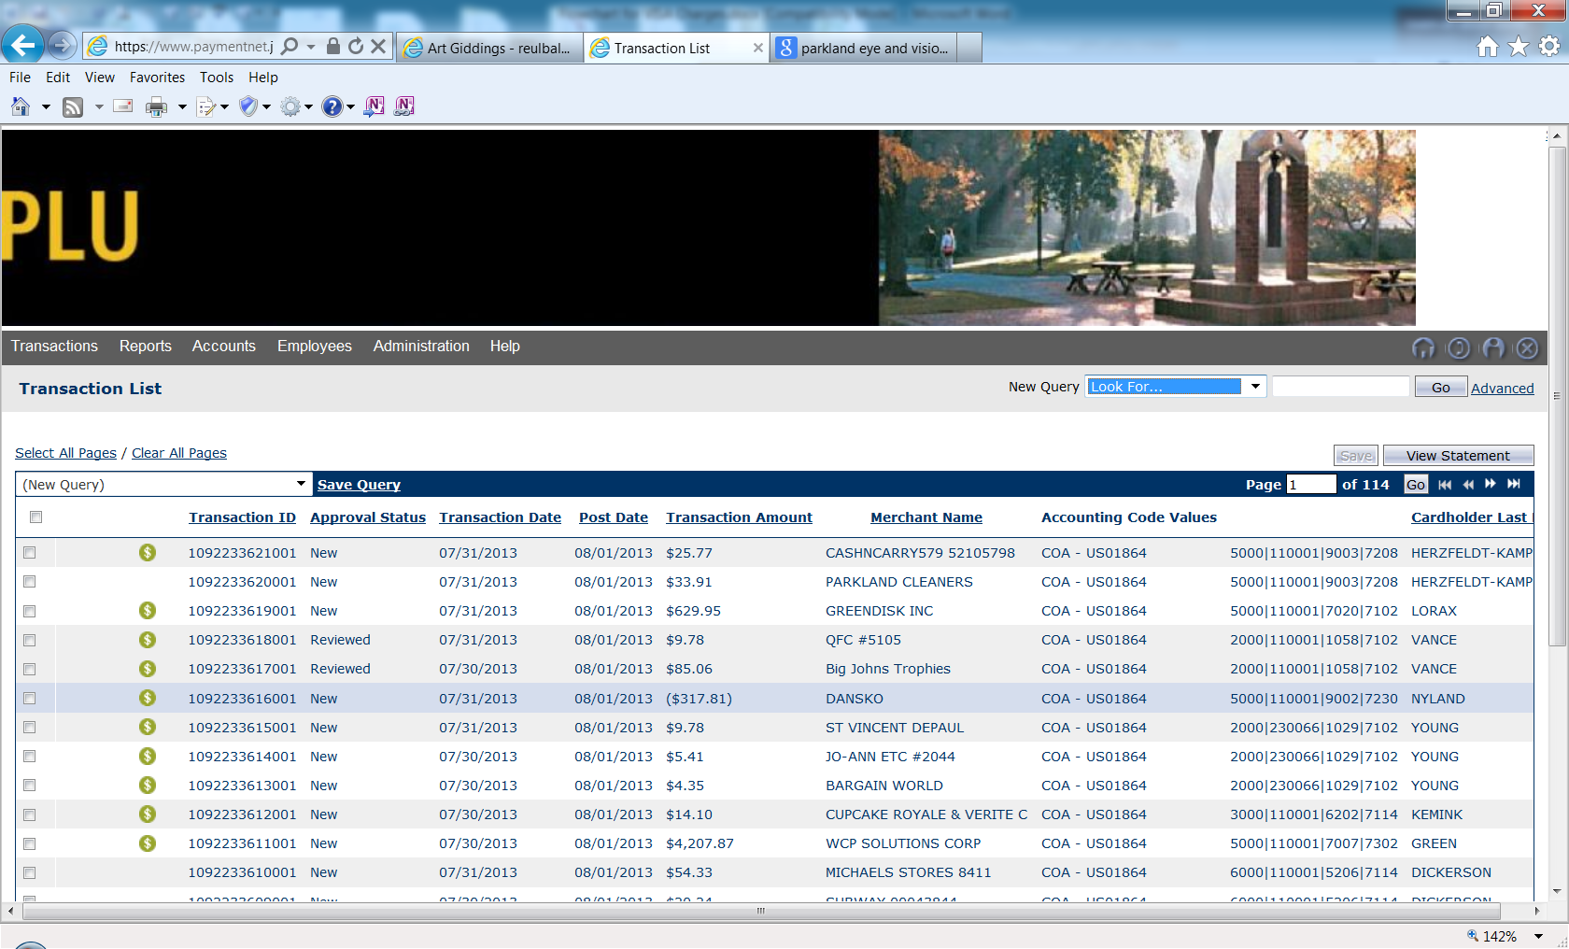

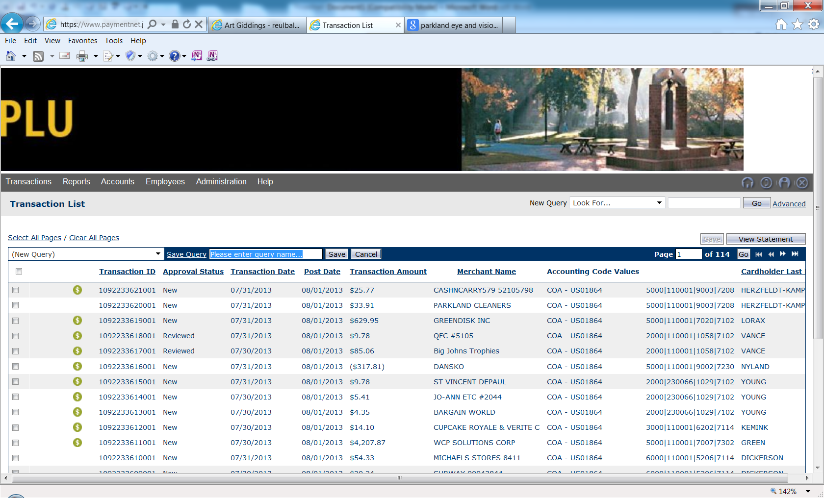

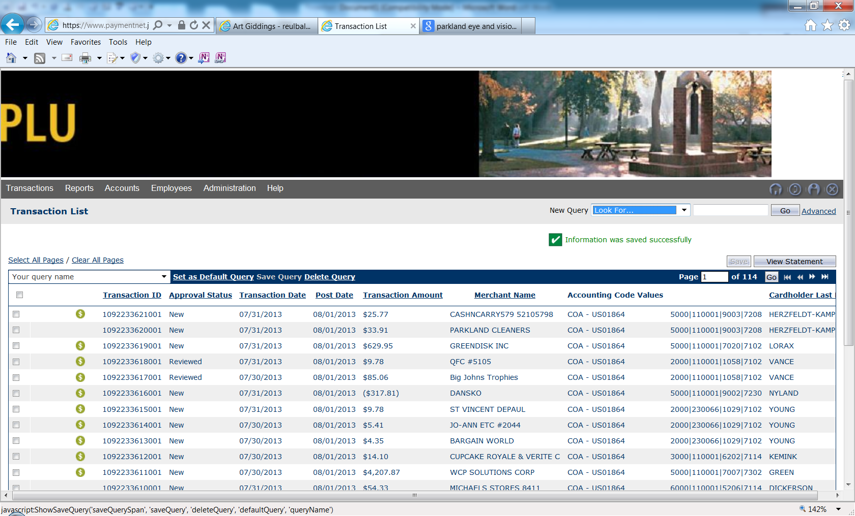

**\* If you are unable to change Accounting codes:**

Set Explorer  
compatibility view.

If your Menu bar   
does not appear:  
**Right** click  
the settings icon.  
Click Menu bar from  
the drop-down list. .  
  
Select Tools from the Menu   
bar. Then click the Compatibility view from the drop-down list.

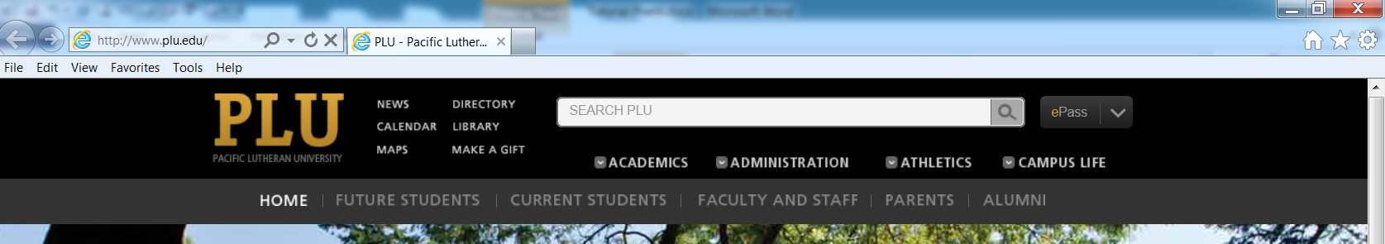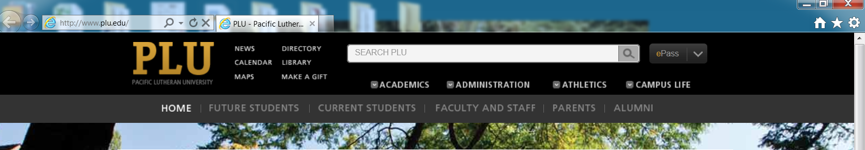

If you have questions or need assistance, please contact the Business Office, Purchase Card Coordinator, Louise Reulbach at 253-535-8867.