Pacific Lutheran University School of Nursing
Performance Progression Alert

The School of Nursing (SoN) faculty may enact a Performance Progression Alert (PPA) for students who are not meeting the Essential Qualifications, Professional Conduct and Values of the Nursing Profession, and Integrity and Academic Integrity as noted in the SoN Student Handbook. All faculty are responsible for identifying and addressing occurrences. Issues of Academic Integrity will be referred to the Office of Student Rights and Responsibilities and an Academic Dishonesty Form may be completed. For further information, please consult the SoN Student Handbook.

- The PPA will specify:
  - The nature of the performance concern
  - Criteria for satisfactory performance
  - The timeline for achieving expected improvements
  - Consequences for failure to improve

- A single major alert or three minor alerts during the program of study will result in:
  - Review by the RAP committee and/or the Dean of Nursing
  - Possible dismissal from the School of Nursing
Major violations, and any occurrences that place the client, self, or others in potential immediate danger will result in immediate notification of the SoN Dean.

Major occurrences may include, but are not limited to:
- Unsatisfactory clinical performance
- Professional misconduct and safety issues as defined in the SoN Student Handbook
- Failure to report an incident
- HIPAA violations
- Violations of the law or other legal regulatory requirements
- Breaches in research/HPRB protocol
- Life-threatening errors
- Other unsafe behaviors

Minor occurrences may include, but are not limited to:
- Unprofessional communication behaviors
- Unprofessional dress
- Inappropriate utilization of technology
- Not being prepared for learning
- Failure to demonstrate the expected level of competency
- Turning in late, incorrect, or incomplete assignments
- Tardiness and/or absences (excused and unexcused)
- Inappropriate behaviors and/or lack of judgment relative to assigned clinical activities, professional relationships, or interactions that are part of the learning environment
- Poor performance (in danger of course and/or clinical failure)
- Other disruptive behaviors
Pacific Lutheran University School of Nursing
Performance Progression Alert

Information on Occurrence: ☐ Major PPA ☐ Minor PPA Student’s level in SoN program:
Occurrence Date _________________ Report Date:_______________ ☐ Sophomore I ☐ Sophomore II
Student Name: ___________________________________________ ☐ Junior I ☐ Junior II
Course Number: ___________________________________________ ☐ Senior I ☐ Senior II
Issuing Faculty: ___________________________________________ ☐ ELMSN ☐ MSN ☐ DNP
Details:
- Reason for alert:

- Issuing faculty comments:

- Student comments:

- Student goals:

- Timeline for completion:

- Consequences for failure to achieve student goals and timeline:

Student Signature: __________________________________________ Date: ____________________

Issuing Faculty Signature: ____________________________________ Date: ____________________
Attached Supporting Documents (required, if major; optional, if minor):
☐ Course syllabus ☐ HPRB protocol (if applicable)
☐ Relevant email communications (if applicable) ☐ Hospital/clinical policy (if applicable)
☐ Other: _____________________________________________________________________________
Reporting Documentation:
Original form submitted to SoN office for placement in the student’s file: ____________________(Date)

The following individuals were notified by issuing faculty:
☐ Academic Advisor (required): __________________________________________________________
☐ Lead Course Faculty (as appropriate): ____________________________________________________
☐ Prelicensure Program Lead
☐ Postlicensure Program Lead
☐ ABSN Coordinator (as appropriate)
☐ School of Nursing Clinical Placement Coordinator (as appropriate)
☐ Assoc. Director of Advising, Admission, and Student Support (required)
☐ Chair of RAP
☐ Assistant Dean of Prelicensure Programs (for prelicensure programs only – ABSN, TBSN, and the prelicensure portion of the ELMSN
☐ Director of Graduate Programs (for graduate students only)
☐ Dean of the School of Nursing (if major)

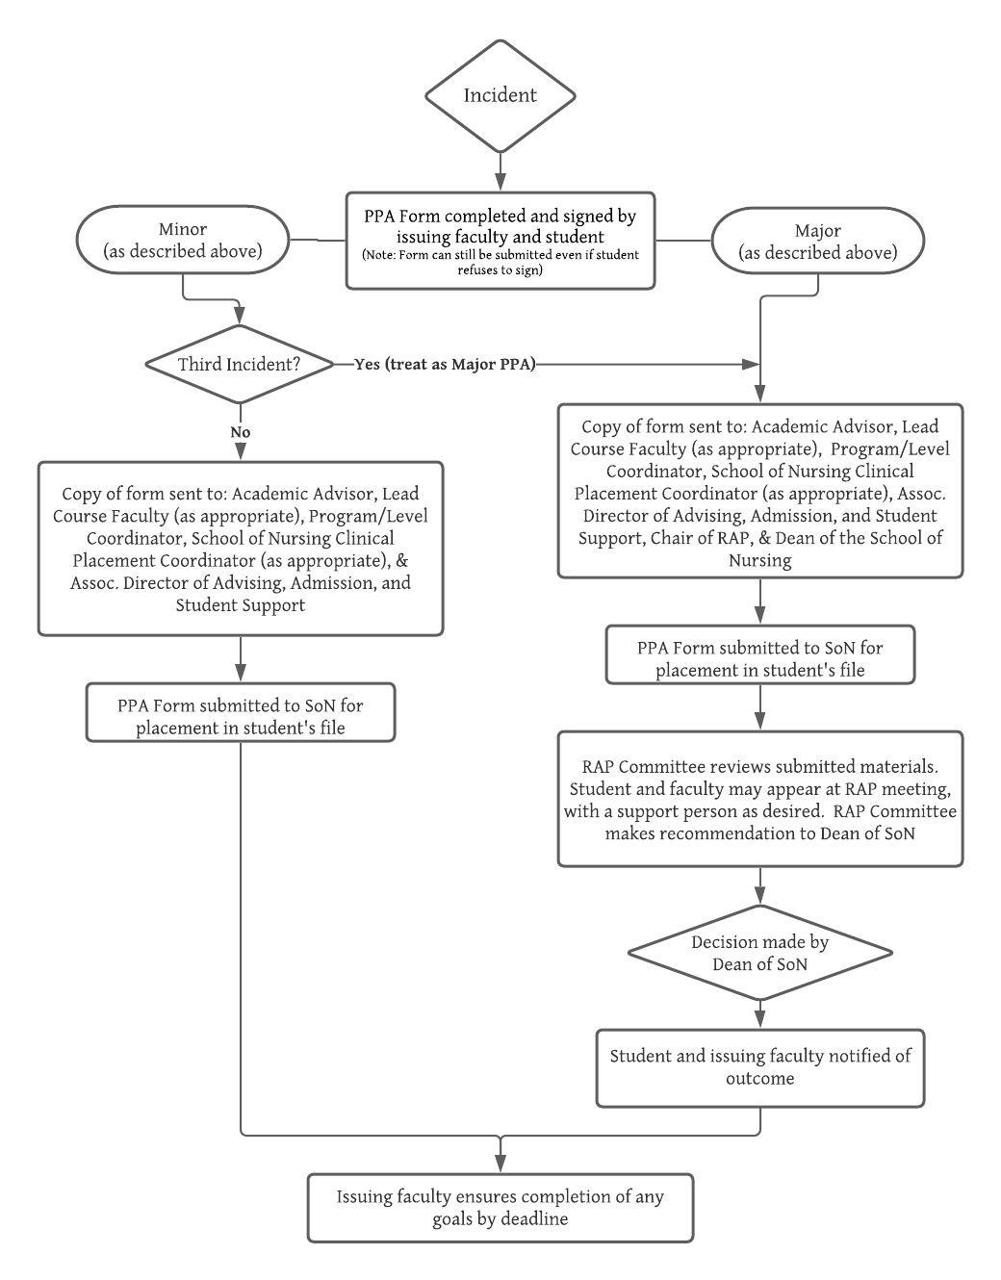

INTERNAL RAP COMMITTEE USE:

To be completed by Assoc. Director of Advising, Admission, and Student Support:
- Prior PPAs? ____________________________________________________________________
- Other relevant info: ______________________________________________________________
RAP Committee Member Assigned for Follow-Up: _________________________________________
☐ Issuing faculty notified of outcome by the RAP Committee

