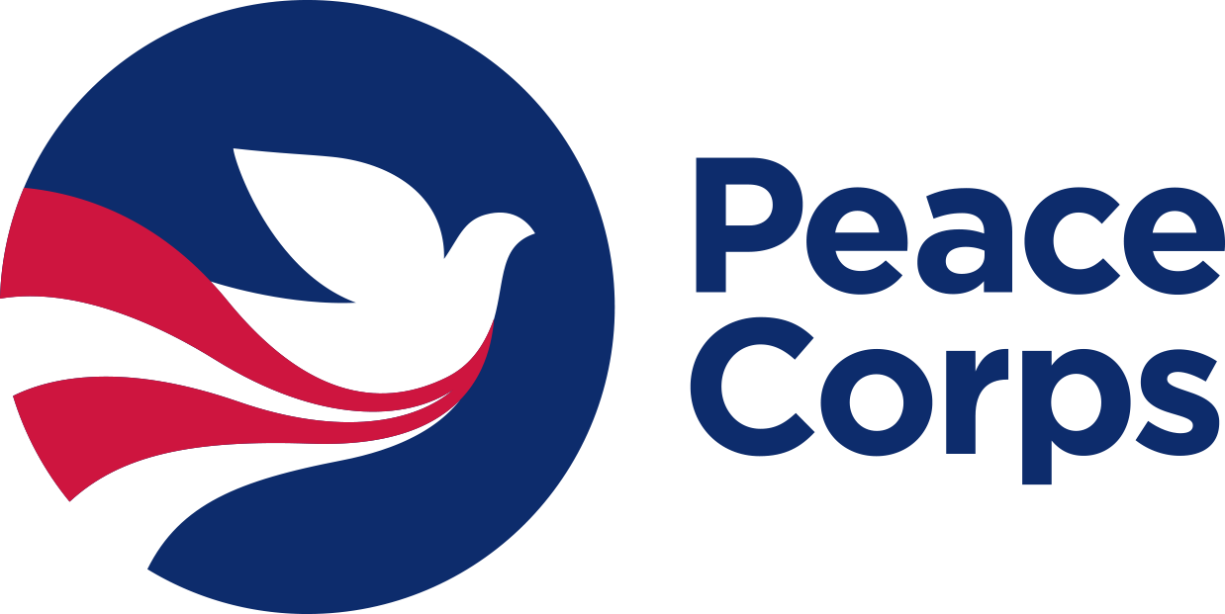
Student Name: _______________________________
Permanent Email: ____________________________
University: Pacific Lutheran University
PC Prep Program Director: Priscilla St. Clair

Peace Corps Prep Checklist

Below are the Peace Corps Prep certification requirements. If you apply to Peace Corps, please scan and attach this signed form to your application with the name “PC Prep Checklist.” If you apply to Peace Corps before completing a requirement below, write: “[Activity]: planned [month/year].”

- Training and experience in a specific work sector
Please check the box of the sector in which you have prepared yourself to serve:
- Education
- Health
- Environment
- Agriculture
- Youth in Development
- Community Economic
Development
- Coursework. List the 3 highest approved sector-aligned course #s and titles you took (Refer to Student Guide for list of approved classes):

- ________________________________

- ________________________________

- ________________________________

- Hands-on experience in that same sector. Total Hours (must be at least 50): _______
Description of experience:

- Foreign language skills
List the four credits of foreign language (or equivalent) that you took.
Language: _____________________ Course (or equivalent): ___________________

List any other language courses or additional experience:

- Intercultural competence
List your 3 approved courses/experiences that bolstered your intercultural competence (Refer to Student Guide for list of approved classes):

- _____________________________
(Core course)

2. _____________________________
3. _____________________________

- Professional and leadership development

- Professional resume feedback:   Yes  No Date: Where:

- Professional interview prep:   Yes   No Date: Where:

- Demonstrated leadership experiences (i.e., student orgs, work, volunteer, etc.) Describe:

_____________________ _________ __________________________ ______
Signature of Student Date Signature of PC Prep Program Director Date

