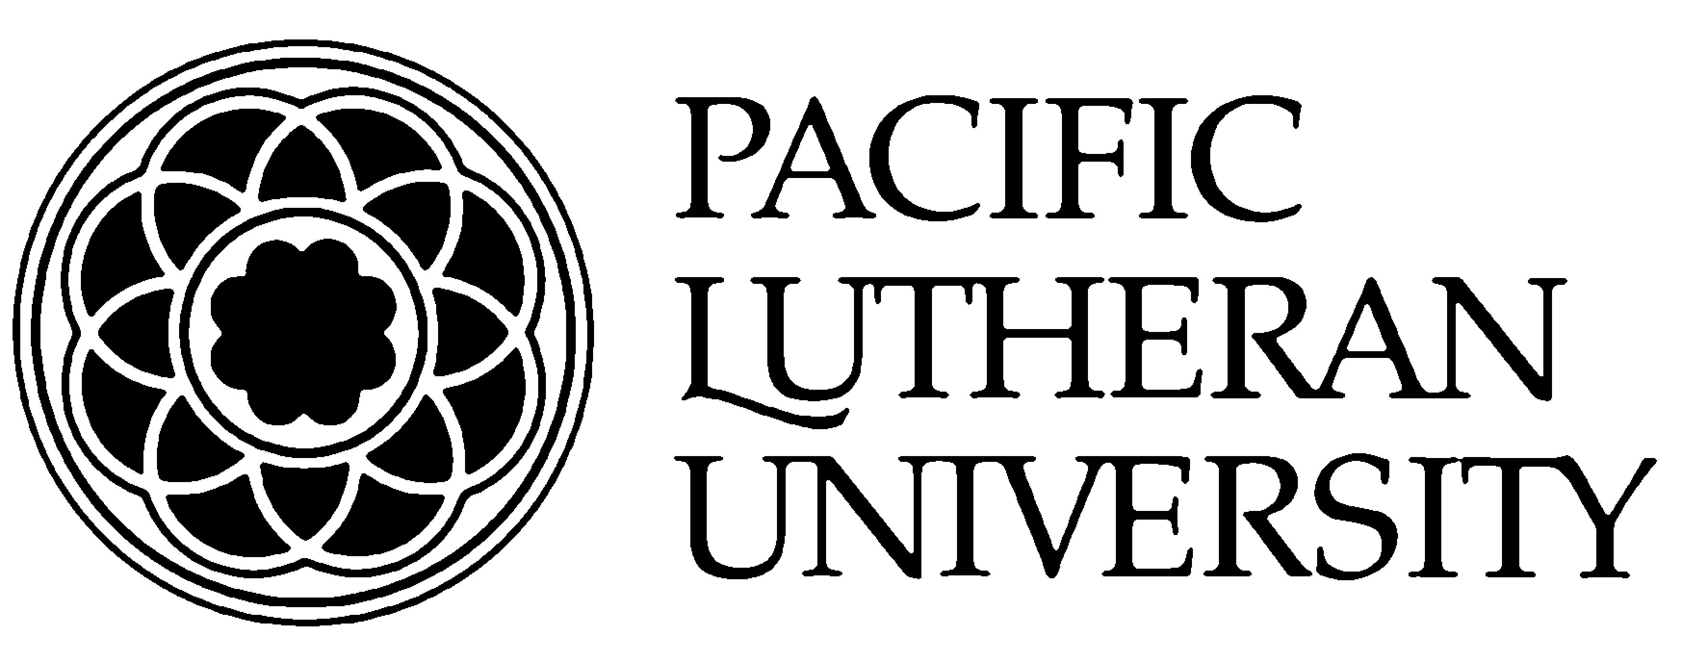
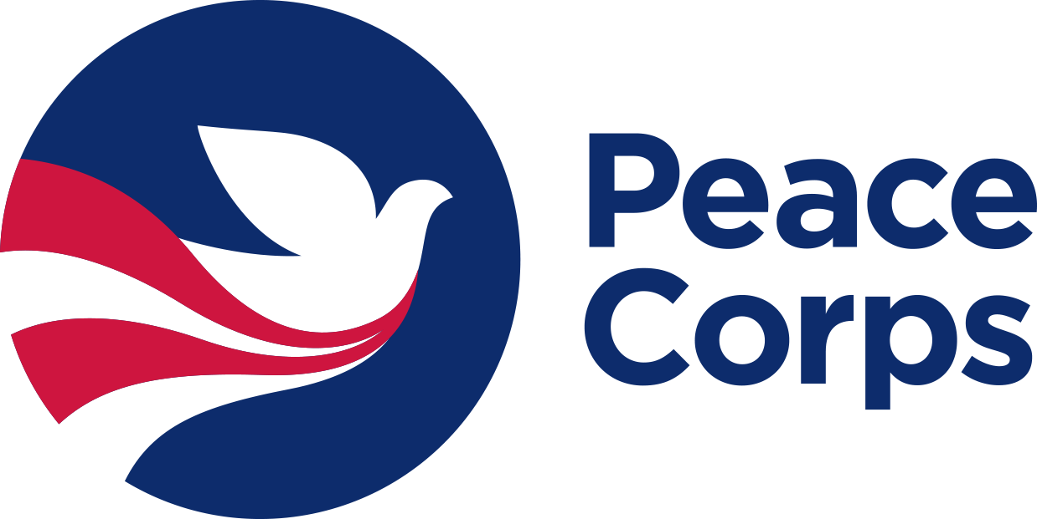

Peace Corps Prep Student Guide

The Peace Corps Prep program will prepare you for international development fieldwork and potential Peace Corps service. To accomplish this, you’ll build four core competencies through interrelated coursework, hands-on experience, and professional development support. These four competencies, or “learning objectives,” are the following:

      - Training and experience in a work sector
      - Foreign language skills
      - Intercultural competence
      - Professional and leadership development

This document explains each of these requirements in detail. Use this guide to map out your Peace Corps Prep course of study. In particular, refer to this when completing your PC Prep application, where you’ll need to document how you plan to fulfill each requirement. This guide aligns point-by-point with each section of the application!

            - Training and experience in a specific work sector
3 courses + 50 hours related experience

Leveraging concrete knowledge and skills is central to on-the-ground international development work. Through this PC Prep program, you will begin to build a professional specialty, which should serve your career well whether or not you become a Peace Corps Volunteer.

For PC Prep, you need to complete at least 3 courses (for a total of 12-credit hours) that align with a specific work sector (they can but do not need to come from your academic major or minor). You also must accumulate a minimum of 50 hours of volunteer, work, or internship experience in that same sector, preferably in a teaching or outreach capacity. The Center for Community Engagement and Service at PLU can provide support and resources in helping you to identify volunteer work while Alumni and Student Connections can help you to identify relevant internships and employment.

If you intend to apply to the Peace Corps, the best way to assure that you will be a strong candidate is to identify the type of assignments in which you’d like to serve through this interactive tool (www.peacecorps.gov/volunteer/volunteer-openings) then review the positions’ desired qualifications and build them up accordingly. In the process, you should fulfill these PC Prep experiential requirements!
Peace
Corps
Tip!

There are six sectors in which Peace Corps Volunteers serve—detailed below. Choose one sector to focus on then complete at least 12 credits of courses (three classes) + 50 hours of related experience in that sector. If you find a course that is not listed that you think would also fulfill this requirement, please discuss it with the PC Prep Program Director.
Note: Actual Peace Corps assignments are based on local needs, and thus may or may not align seamlessly with your qualifications. Flexibility is central to the Peace Corps experience!

#1 Education (www.peacecorps.gov/volunteer/learn/whatvol/edu_youth/assignments/)

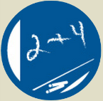
Teach lessons that last a lifetime. Education is the Peace Corp’s largest program area. Volunteers play an important role in creating links among schools, parents, and communities by working in elementary, secondary, and postsecondary schools as math, science, conversational English, and resource teachers or as early grade reading and literacy teacher trainers. Volunteers also develop libraries and technology resource centers.

If you choose Education, take 3 courses (12 credits) from one of the following areas:
  - Biology
  - Chemistry
  - Computer Science
  - Education
  - English
  - Geosciences
  - Math
  - Physics

And build 50 hours of related field experience through an activity such as:
- Teaching in one of these or a similar form: in a classroom, with a community outreach organization, or in a formal tutoring capacity
  - The subject of the teaching may be English as a Foreign/Second Language, special education, drama, or a STEM subject
  - Note that PLU has partnerships with some local schools which would be good places in which to conduct your field experience
- Campus-based education opportunities
    - Academic Assistance
    - Center for Gender Equity
    - Diversity Center
    - Language Resource Center
    - Writing Center
    - PLU Parkland Education Initiative
      - Big Buddies/America Reads/America Counts
      - Club Keithley
    - Parkland Literacy Center
  - PLU partners and initiatives
    - Communities in Schools
    - Franklin Pierce Schools
    - Peace Community Center
    - Puget Sound Education Service District Afterschool Programs
    - Tacoma Community House Read 2 Me
    - Tacoma MESA
    - YMCA Center for Community Impact
#2 Health (www.peacecorps.gov/volunteer/learn/whatvol/health/assignments/)

Serve on the front lines of global health. Health Volunteers work within their communities to promote important topics such as nutrition, maternal and child health, basic hygiene, and water sanitation. Volunteers also work in HIV/AIDS education and prevention programs to train youth as peer educators, develop appropriate education strategies, provide support to children orphaned by the pandemic, and create programs that provide emotional and financial support to families and communities affected by the disease.

If you choose Health, take three courses (12 credits) from any of the following:
  - Biology: BIOL 111: Biology and the Modern World; BIOL 201: Introductory Microbiology; BIOL 205: Human Anatomy and Physiology I; BIOL 206: Human Anatomy and Physiology II; BIOL 225: Molecules, Cells, and Organisms; BIOL 341: Developmental Biology; BIOL 342: Microbiology; BIOL 352: Comparative Anatomy; BIOL 357: Histology; BIOL 444: Neurobiology; BIOL 448: Immunology; BIOL 449: Virology; BIOL 453: Mammalian Physiology
  - Chemistry: CHEM 105: Chemistry of Life; CHEM 403: Biochemistry I; CHEM 405: Biochemistry II
  - Kinesiology: KINS 227: Foundations of Kinesiology; KINS 278: Injury Prevention and Therapeutic Care; KINS 292: First Aid; KINS 315: Body Image; KINS 320: Nutrition, Health, and Performance; KINS 324: Physical Activity and Lifespan; KINS 362: Healing Arts of the Mind and Body; KINS 366: Health Psychology; KINS 384: Foundations of Health and Fitness Promotion; KINS 395: Comprehensive School Health
  - Nursing: Any nursing courses
  - Additional Courses: ANTH 380: Sickness, Madness and Health; HIST 326: A History of Medicine: Antiquity to European Renaissance; SOCW 329: Compassionate Practice-Spirituality and Contemplation in the Helping Professions; SOCW 325: Social Education and Health Services in Tobago

And build 50 hours of related field experience through an activity such as:
- Volunteer or work experience in such areas as HIV/AIDS outreach, hospice, family planning counseling, emergency medical technician (EMT) or CPR teaching/certification, maternal health, and hands-on caregiving in a hospital, clinic, or lab technician setting
- Counseling or teaching in health subjects
- Working as a resident advisor in a dormitory, as a peer nutritionist, or as a sexually transmitted infections counselor
- Significant experience in mechanical repairs, construction, carpentry, masonry, plumbing, hydrology, or set design
- Campus-based health opportunities
    - Center for Gender Equity
    - Peer Advocacy & Community Education (PACE)
  - PLU partners and initiatives
    - PLU Healthy Parkland Initiative
      - Trinity Lutheran Church
      - Nourish Pierce County
      - Emergency Food Network
    - Catholic Community Services
    - Community Health Care
    - Lindquist Dental Clinic for Children
    - Molina Healthcare

#3 Environment (www.peacecorps.gov/volunteer/learn/whatvol/env/assignments/)

Help forge a global movement to protect our planet. Volunteers lead grassroots efforts in their communities to protect the environment and strengthen understanding of environmental issues. They teach environmental awareness in elementary and secondary schools and to youth groups and community organizations, empowering communities to make their own decisions about how to protect and conserve the local environment. Volunteers also address environmental degradation by promoting sustainable use of natural resources.

If you choose Environment, take three courses from any of the following:
  - Biology: BIOL 116: Introductory Ecology; BIOL 226: Genes, Evolution, Diversity, and Ecology; Any course in the Ecology and Evolution trace of the major
  - Environmental Studies: Any ENVT course; ANTH 368: Edible Landscapes, the Foraging Spectrum; BUSA 362: Sustainable Marketing; CHEM 104: Environmental Chemistry; ECON 111: Principles of Microeconomics: Global and Environmental; ECON 311: Energy and Natural Resource Economics; ECON 313: Environmental Economics; ECON 315: Investigating Environmental & Economic Change in Europe; ENGL 234: Environmental Literature; GEOS 104: Conservation of Natural Resources; GEOS 332: Geomorphology; GEOS 334: Hydrogeology; HIST 370: Environmental History of the US; PHIL 226: Environmental Ethics; PHIL 327: Philosophy, Animals and the Environment; POLS 346: Environmental Politics and Policy; RELI 239: Environment and Culture; RELI 247: Christian Theology (when topic is “Women, Nature, and the Sacred” only); RELI 365: Christian Moral Issues (when topic is “Christian Ecological Ethics” only); RELI 393: Topics in Comparative Religions (when topic is “Native Traditions in PNW” only); SCAN 363: Culture, Gender, and the Wild
  - Geosciences: GEOS 103: Earthquakes, Volcanoes and Geologic Hazards; GEOS 107: Global Climate Changes; GEOS 201: Geologic Principles; GEOS 340: Glacial Geology

And build 50 hours of related field experience through an activity such as:
- Educating the public on environmental or conservation issues, or working on environmental campaigns
- Conducting biological surveys of plants or animals
- Gardening, farming, nursery management, organic or low-input vegetable production, or landscaping; Volunteering at PLU’s community garden
- Working or volunteering at the area’s national parks, including Mount Rainier and Olympic National Park
- Providing technical assistance and training in natural resource management
- Campus-based environment opportunities
    - PLU Facilities Management
    - PLU dCenter (Diversity Center)
    - PLU Sustainability
  - PLU partnerships and initiatives
    - Center for Urban Waters
    - Citizens for a Healthy Bay
    - Metro Parks Tacoma
    - Pierce County Parks and Recreation
    - Pierce Conservation District
    - Puyallup Watershed Initiative

#4 Agriculture (www.peacecorps.gov/volunteer/learn/whatvol/agr/assignments/)

Lead grassroots efforts to fight hunger in a changing world. Agricultural Volunteers work with small-scale farmers and families to increase food security and production and adapt to climate change while promoting environmental conservation practices. They introduce farmers to techniques that prevent soil erosion, reduce the use of harmful pesticides, and replenish the soil. They work alongside farmers on integrated projects that often combine vegetable gardening, livestock management, agroforestry, and nutrition education.

If you choose Agriculture, take three courses (12 credits) from any of the following:
ANTH 368: Edible Landscapes, The Foraging Spectrum; BIOL 116: Introductory Ecology; BIOL 356: Economic and Cultural Botany; BIOL 358: Plant Physiology; BIOL 367: Conservation Biology and Management; BIOL 368: Ecology; BIOL 443: Plant Development & Genetic Engineering; BIOL 462: Plant Diversity and Distribution; ECON 111: Principles of Microeconomics - Global and Environmental; ECON 311: Dynamic Modeling Natural Resources; ENVT/GEOS 104: Conservation of Natural Resource

And build 50 hours of related field experience through an activity such as:
- Working with a large-scale or family-run business involving vegetable gardening, farming, nursery work, tree planting or care, urban forestry, landscaping, livestock care and management, or fish cultivation and production
- Volunteering in PLU’s community garden
- Teaching or tutoring the public in environmental or agricultural issues/activities
- Working on the business management or marketing side of a commercial farm
- Campus-based agriculture opportunities
    - PLU Habitat Restoration
    - PLU Community Garden
  - PLU partners and initiatives
    - Franklin Pierce Farm
    - Harvest Pierce County
    - Hilltop Urban Garden
    - L’Arche Farm
    - Mother Earth Farm

#5 Youth in Development (www.peacecorps.gov/volunteer/learn/whatvol/youth/assignments/)
Empower the next generation of changemakers. Volunteers work with youth in communities on projects that promote engagement and active citizenship, including gender awareness, employability, health and HIV/AIDS education, environmental awareness, sporting programs, and info technology.

If you choose Youth in Development, take three courses (12 credits) from any of the following:
- Education: Any course in Elementary Education or Secondary Education
  - Global Studies: Any course in the Development and Social Justice Concentration
  - Kinesiology: Any course in the Health and Fitness Education Concentration
  - Women’s and Gender Studies: Any course that counts for the major
  - Additional Courses: ENGL 235: Children’s Literature; ENGL 334: Special Topics in Children’s Literature; PSYC 101: Introduction to Psychology; PSYC 420: Adolescent Psychology; SOCI 101: Introduction to Sociology; SOCI 226: Delinquency and Juvenile Justice; SOCI 240: Social Problems; SOCI 330: The Family; SOCW 320: Child Welfare, A Global Perspective; SOCW 375: Social Services in the Community; SOCW 460: Social Work Practice II: Families and Groups

And build 50 hours of related field experience through an activity such as:
- Teaching or counseling in at-risk youth programs
- Activities that involve planning, organizing, assessing community needs, counseling, and leadership, in areas such as education, youth development, health and HIV/AIDS, the environment, and/or business
- Volunteering on PLU’s Sexuality Awareness & Personal Empowerment Team or for other Women’s Center Programs
- Campus-based youth in development opportunities
    - Diversity Center
    - PLU Parkland Education Initiative
      - Big Buddies/America Reads/America Counts
      - Club Keithley
    - Parkland Literacy Center
  - PLU partners and initiatives
    - Communities in Schools
    - Franklin Pierce Schools
    - Peace Community Center
    - Puget Sound Education Service District Afterschool Programs
    - Tacoma Community House Read 2 Me
    - Tacoma MESA
    - YMCA Center for Community Impact
#6 Community Economic Development
(www.peacecorps.gov/volunteer/learn/whatvol/busdev_01/assignments/)
Harness 21st-century tools to help communities lift themselves. Volunteers work with development banks, nongovernmental organizations, and municipalities to strengthen infrastructure and encourage economic opportunities in communities. They frequently teach in classroom settings and work with entrepreneurs and business owners to develop and market their products. Some Volunteers also teach basic computer skills and help communities take advantage of technologies such as e-commerce, distance learning, and more.

If you choose Community Economic Dev., take three courses (12 credits) from any of the following:
- Business Administration
  - Communications
  - Computer Science
  - Economics
  - Global Studies (any course in the Development and Social Justice Concentration)
  - Studio Arts (any course in Graphic Design)
  - Additional Courses: PSYC 345: Community Psychology

And build 50 hours of related field experience through an activity such as:
- Working with businesses, organizations, or cooperatives in accounting, finance, microfinance, management, project management, budgeting, or marketing
- Starting and running your own business or other entrepreneurial activity
- Training others in computer literacy, maintenance, and repair
- Working in Information and Technology Services at PLU
- Website design or online marketing
- Founding or leading a community- or school-based organization
- Campus-based community economic development opportunities
    - Parkland Community Development Initiative
    - PLU Habitat for Humanity Club
- PLU partnerships and initiatives
  - Habitat for Humanity
    - Sound Outreach
    - Tacoma Community House
    - United Way of Pierce County

Nearly two-thirds of Peace Corps Volunteers serve in Education or Health. Coursework and meaningful experience in one of these areas—especially teaching English as a second/foreign language—produce some of the strongest candidates.
Peace
Corps
Tip!

To learn about additional volunteer opportunities in the PLU community, visit http://www.plu.edu/service

Foreign language skills
Working across cultures often entails verbal and nonverbal languages distinct from your own. Building foreign language skills is thus a second key component of the PC Prep curriculum.

Requirement: Four credits in a foreign language, or equivalent demonstrated proficiency.

Additional language considerations: Where would you like to serve? PC language requirements vary by linguistic region so applicants to some regions are strongly encouraged to take additional language classes.
- Latin America: Individuals wanting to serve in Spanish-speaking countries must apply with strong intermediate proficiency. This typically means completing two 200-level courses.
- West Africa: Individuals wanting to serve in French-speaking African countries should be proficient in French (or, in some cases, any Romance Language), usually through one 200-level course.
- Everywhere else: The Peace Corps has no explicit language requirements for individuals applying to serve in most other countries. However, you will still likely learn and utilize another language during service, so it is only helpful to have taken at least one foreign language class.

            - Intercultural competence
3 approved courses

Engaging thoughtfully and fluidly across cultures begins with one’s own self-awareness. With this learning objective, you will deepen your cultural agility through a mix of three introspective courses in which you learn about others while reflecting upon your own self in relation to others. The goal is for you to build your capacity to shift perspective and behavior around relevant cultural differences.

You’ll take at least 1 of these core courses (four credits):
- ANTH 102: Human Cultural Diversity
- COMA 304: Intercultural Communication
- ECON 333: Economic Development: Comparative Third World Strategies
- ENGL 233: Postcolonial Literature
- GLST 210: Contemporary Global Issues: Migration, Poverty, and Conflict
- HIST 215: Modern World History
- RELI 230: Religion and Culture

And choose 2 additional electives (8 credits) from the above list or:
- Any course that fulfills the Cross Cultural (C) element of the General Education Program.
- Approved, semester-long study-away programs may be substituted for some of all of these credits.
Prolonged intercultural experiences—such as studying or volunteering abroad, supporting new immigrants or refugees acculturate to the United States, or volunteering in diverse schools—would also strengthen your Peace Corps candidacy significantly. We encourage (but do not require) PC Prep students to take advantage of at least one of PLU’s study away programs, whether it be a semester-long program or a January term program. Many courses taken during study away fulfill some of the above requirements. Please see the PC Prep Program Director to discuss which requirements your program may fulfill.
Peace
Corps
Tip!

            - Professional and leadership development
Resume and interview support + Leadership experience

International development is a highly professional sector. It is difficult to break into and demands great initiative and leadership to advance professionally within the field. PC Prep requires three specific activities that will strengthen your candidacy for the Peace Corps (or any other professional endeavor). All these must be certified by the program director:
- Have your resume critiqued by someone in Alumni and Student Connections.
- Attend a workshop or class on interview skills at Alumni and Student Connections.
- Develop at least one significant leadership experience and be prepared to discuss it thoughtfully. For example, organizing a campus event, leading a work or volunteer project, or serving on the executive board of a student organization

