UPDATED March 7th, 2019

Creating an Event in EMS

EMS is PLU’s new scheduling system. The guide below will walk you through the process of creating an even using EMS.
- Reaching the EMS Website
  - Visit plu.edu and hover over ePass, bringing up a dropdown menu
  - From here, click on Campus Calendar
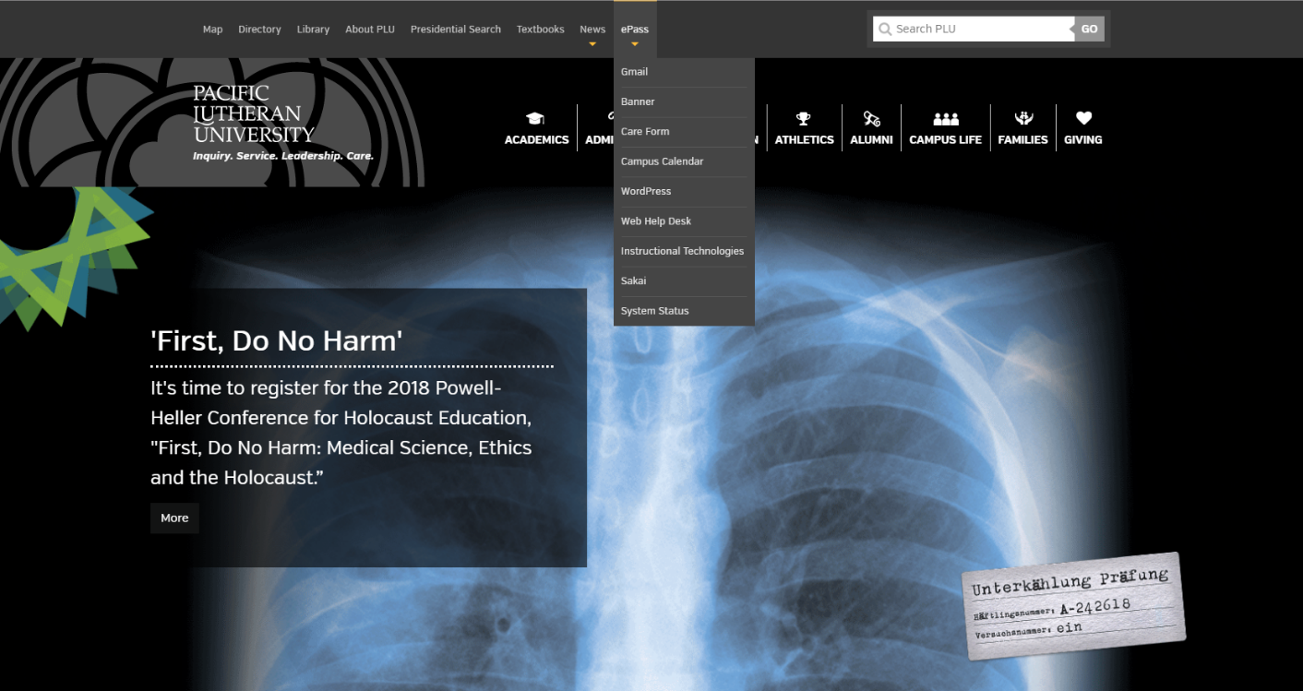
1. Hover over ePass

2. Click on Campus Calendar

  - The top of the following screen will look like the screenshot below, where you will click on the Schedule My Event in EMS tab
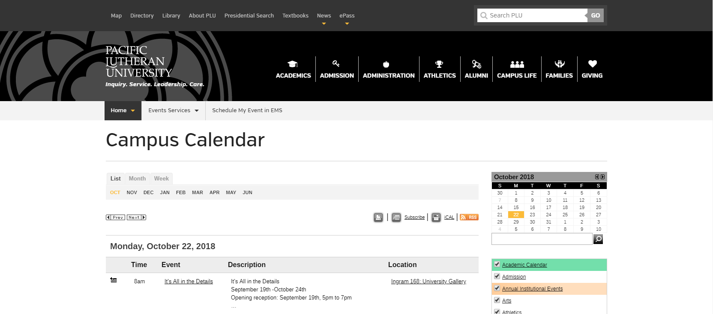

Click here

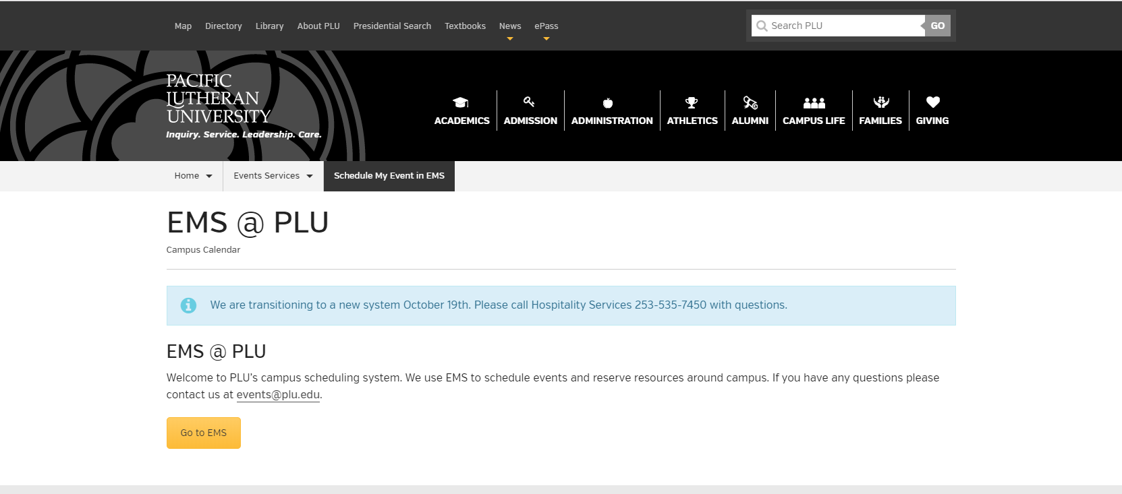

Click here to go to the EMS login page

  - From here, you’ll click on the big yellow button saying Go to EMS to bring you to the login screen

- Logging In:
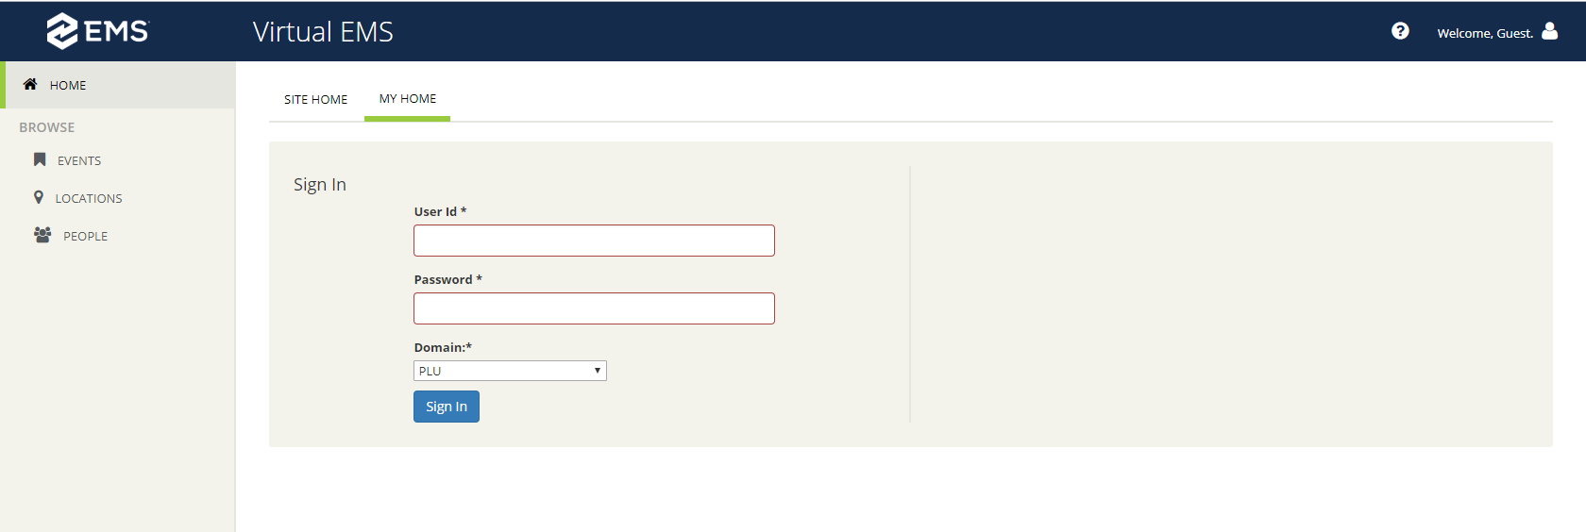

User ID: your PLU email
Password: ePass password

- The log in screen looks like the above screenshot, enter your ePass User ID and password to log in
- EMS Basics
- On the EMS homepage, there are multiple options including Create a Reservation, My Events, and the option to browse Events, Locations, and People.
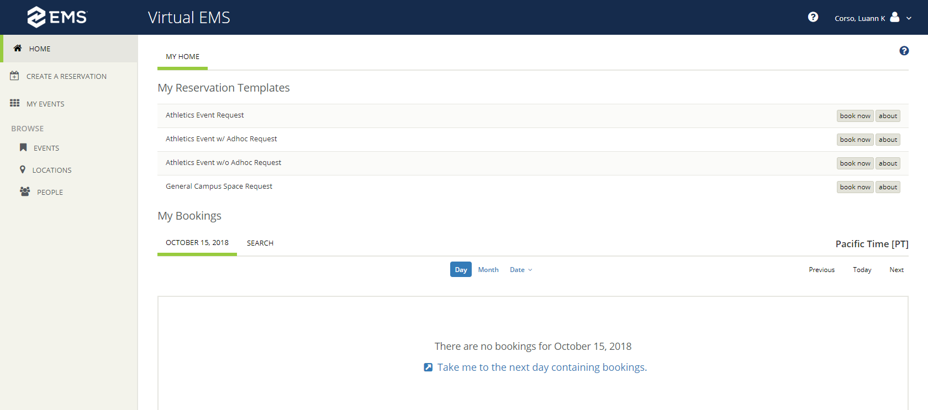

Finding Available Rooms
IF YOU ALREADY KNOW WHAT TIMES YOU WANT AND KNOW IT’S OPEN, SKIP TO PAGE 6 TO SCHEDULE YOUR EVENT
  - To find available rooms, start by clicking on the Locations tab on the home screen.
  - Locations is only a daily view, if you need a monthly/weekly view, skip to the bottom of page 4 to go through the Events tab

Click here to search for locations

- Here, you can search different rooms and areas for availability. You can start by clicking on the Add Rooms or Locations filter on the top of the page

Click here to add different locations

- Clicking on that will bring up a list of locations
  - Athletics Areas: Fields and Outdoor areas
  - Memorial Gym
  - Olson Gym
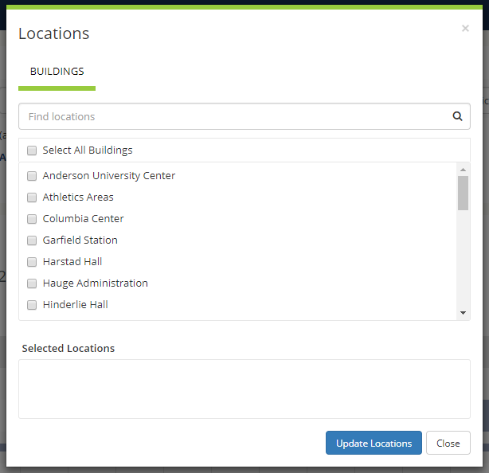

Click here when done
- Once you’re done choosing areas to look for, click on the blue Update Locations button on the bottom of the popup
- This will give you a daily view of the locations you choose
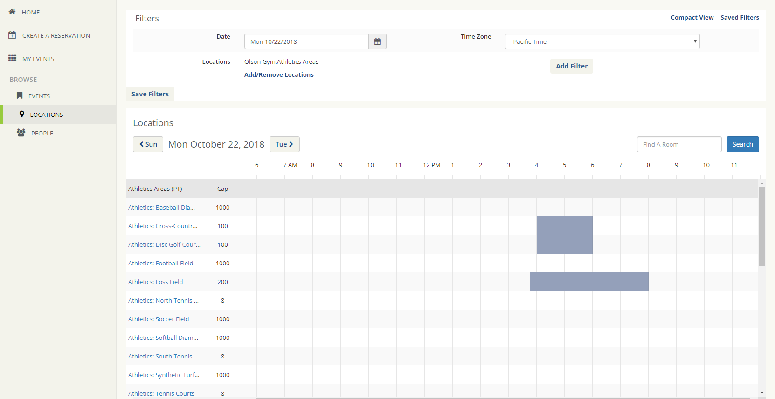

- If you are looking for a weekly or a monthly view of areas, you can click on the Events tab

Click here to see other views of different rooms and locations

- From this screen, you can do things such as switch between daily/weekly/monthly views of the calendar, add filters for rooms, locations, etc., and switch different dates on the calendar.
Click here to add filters like rooms, locations, groups, etc.

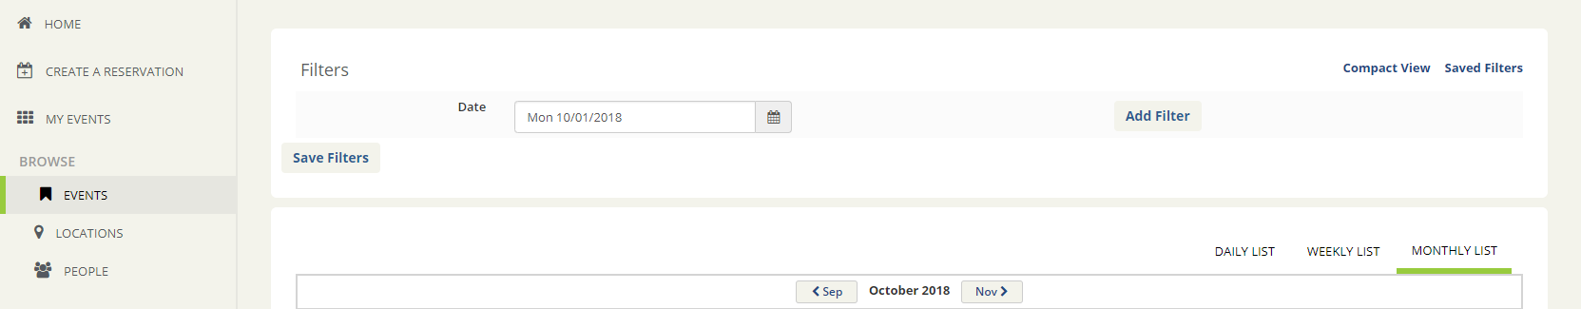
Click here to look at other dates

Click here to switch between daily/weekly/monthly views of the calendar

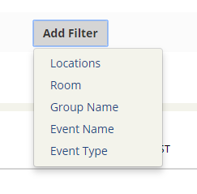
- When adding filters, you can choose from locations, rooms, group name, event name, and event type, with the ability of adding more than one
These are the types of filters

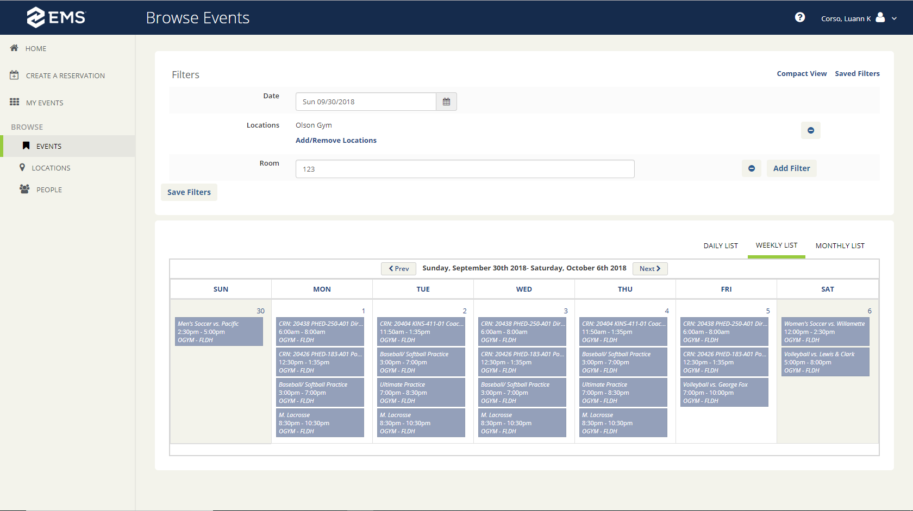
- For example, if you wanted to see a weekly view of the fieldhouse in Olson, you would check Olson Gym under locations, type in ‘123’ in the room box for room 123, and click on the weekly view option. The end result looking like this:

Type what room you want here

REMEMBER THE EXACT ROOM NUMBER YOU ARE BOOKING, YOU WILL NEED IT LATER ON
Create a Reservation
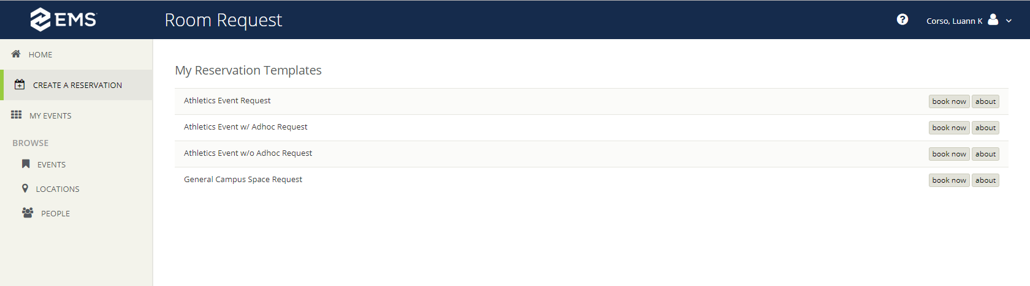
Click here to create a reservation

Click on Book Now to book what type of event you want

- Here, you choose what kind of event you are trying to schedule, an
  - Athletic Event Request: Must be scheduled 48 hours in advance
  - Athletics Event w/ Adhoc Request: Can be scheduled immediately – use for scheduling multiple events
  - Athletics Event w/o Adhoc Request: Can be scheduled immediately – use for single day scheduling
  - General Campus Space Request: Must be scheduled 48 hours in advance
- Once you know what kind of event you are scheduling, click on the Book Now tab on the right side of the screen, bringing you to a page looking like the screenshot below:
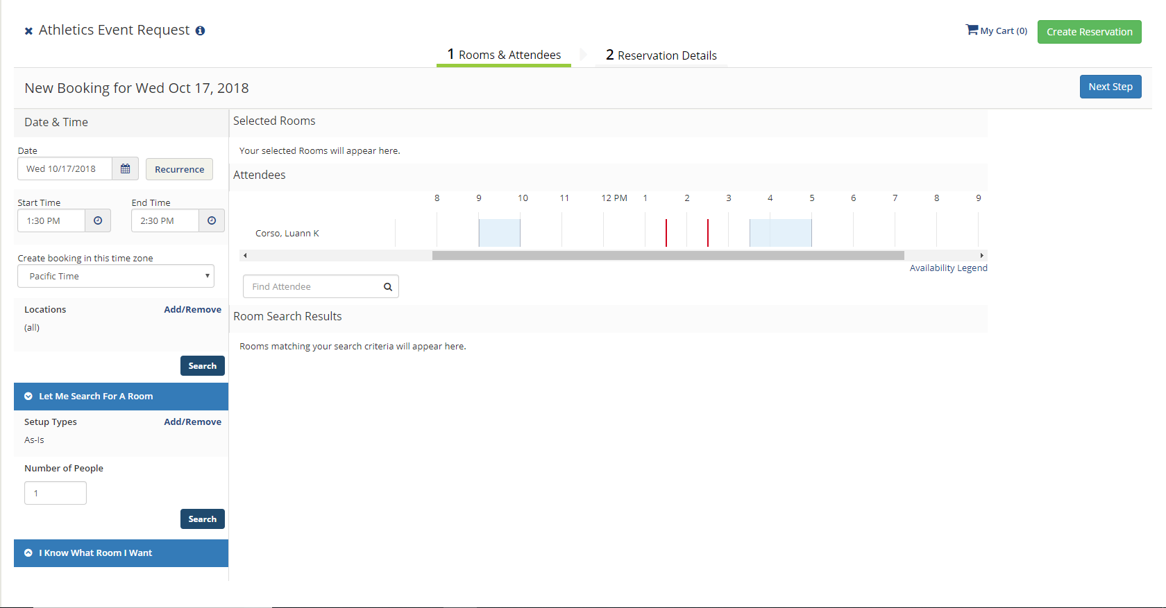
If you already know what room you want, click here
Enter in date and time desired here
Search for a room here
  - From this screen, you can see the many different options for creating an event, where you can choose Date & Time, Search for a Room, and the option to input a specific room
  - The rest of the screen will show a summary of the event and room you are currently booking

  - Date & Time: Pick what times you will be needing the room and on what day, if you need to book multiple days, then click on the recurrence button next to where you put in a date.
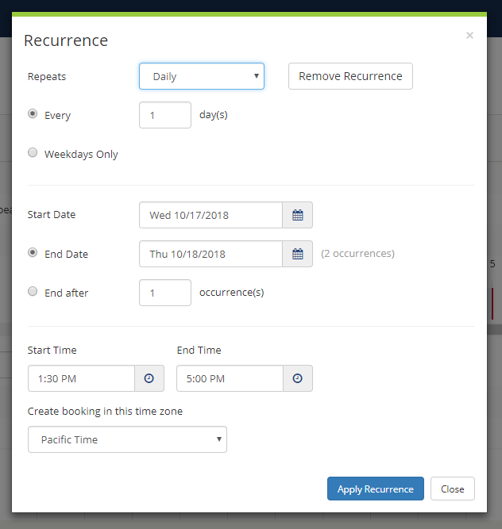
    - Clicking on the recurrence button will pop up a window allowing you to choose when your event will repeat, how many times it will repeat, as well as how long it will repeat

- I Know What Room I Want: When you know exactly what rooms you want to reserve, you input exactly what room you want, adding it to your cart once you find it.

Type in an exact part of what room you want to book, for example the field house is Olson Gymnasium 123: Field House, so you can type ‘123’ to bring it up

Click on the room to continue

Once you add a room to your cart, you cannot go back and change the dates and times, you must change all times and dates before adding a room to your cart.
- Once you select a room, a window will pop up, as shown below

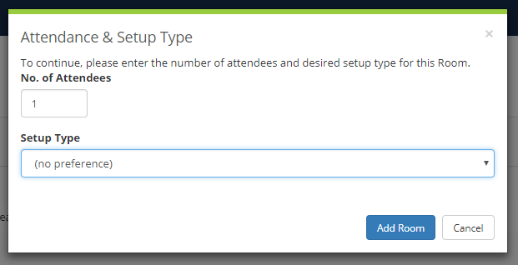
Click here to get a dropdown menu of different setup types

Enter an estimate on the number of people attending

Click “Add Room” when finished

- To add more rooms simply go through the same process
- Once the rooms needed have been added, click the Reservation Details tab

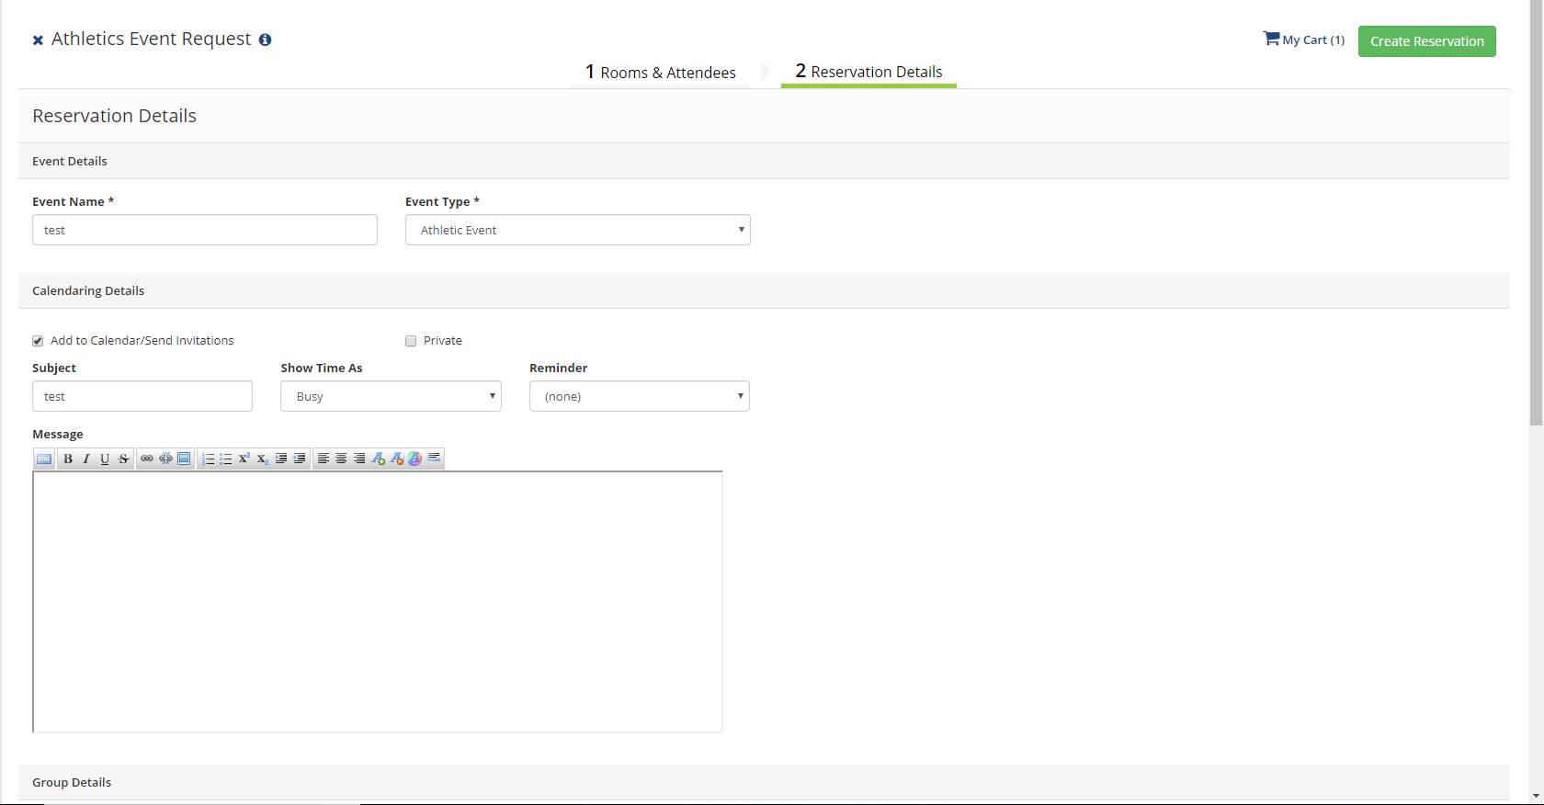
Enter event name here

Enter “Athletic Event” here
Enter any important event details here

Make sure you change the contact information to your own contact information

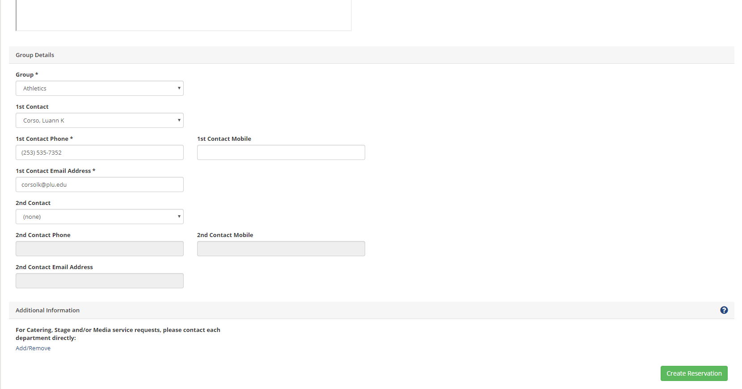

Click the green Create Reservation button in the bottom right corner to finish the reservation

- After clicking the button, a window will pop up confirming the reservation
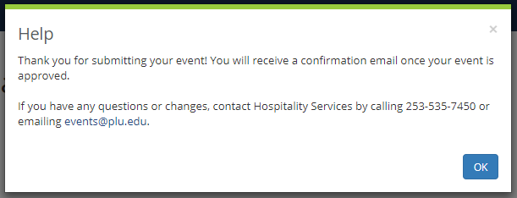

Click OK

Click here to add to your calendar

- What to Type for Room Names in EMS
  - Indoor Facilities will be named after what building they’re in:
    - Field House: Olson Gymnasium 123: Field House or FLDH
    - Main Gym: Olson Gymnasium 137: Gym/ Scott & Sis Names Court or 137
    - Memorial Gym Main Gym: Memorial Gym 100: Gymnasium or 100
  - Outdoor facilities will be under Athletics
    - Turf Soccer Field: Athletics: Synthetic Turf Field or Syn
    - Baseball Field: Athletics: Baseball Diamond or Baseball
    - Softball Field: Athletics: Softball Diamond or Softball
Adding to an Existing Event
- When you already have an event scheduled and you want to add more dates to that event, start by clicking on the My Events tab.
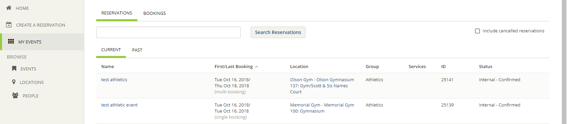
Click here to view your event

- Here, you can see all the events you have scheduled under your account
  - Start by clicking on the blue event name
- Clicking on the event name will bring up the following screen
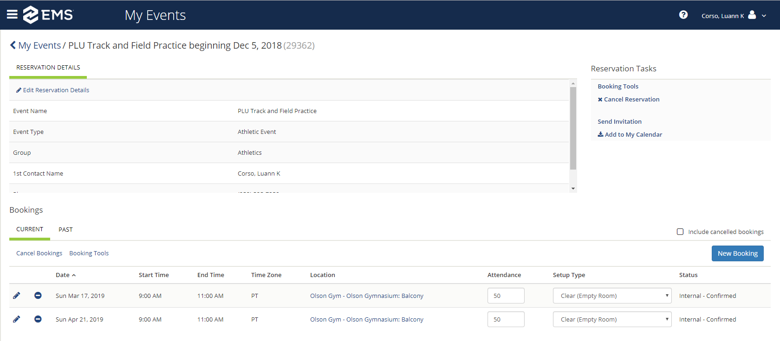
Click here to add new dates to your existing event
Click here to cancel your reservation
Click here to edit the rooms chosen, add more rooms, or delete the existing room
Click here to edit reservation details, such as contact, reservation name, and reservation type

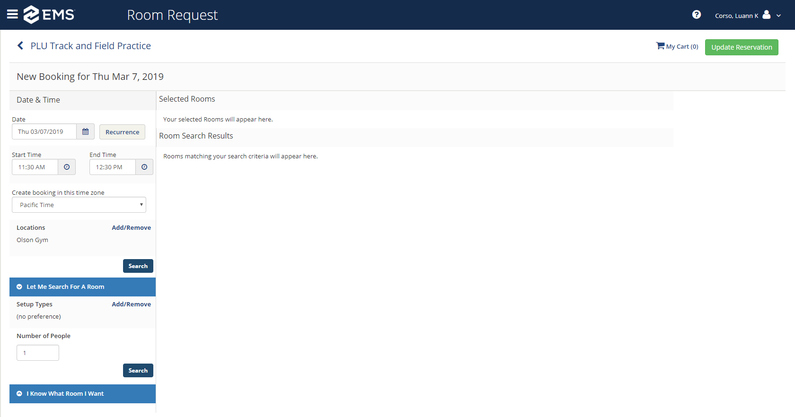
- Clicking on “New Booking” will bring up the usual create a reservation screen, allowing for you to schedule new dates for your existing event

Click here when done
For help scheduling an event, go back to page 6 and follow instructions

