The PLU Safety Committee would like to inform you of things you can do to: Prevent Ergonomic Injuries

Desktop Computer Set-up
(Pictures on back)
- Initially take time to adjust your chair, keyboard tray, and monitor so your posture is aligned in a 90/90/90 position.
- When sitting at your work station your knees, waist and elbows should be at 90 degrees.
- When viewing your monitor you should be looking at the top 1/3 of your screen so your head and neck is not tilted up or down.
- The monitor should also be located at an arm’s reach away so you do not have to strain your eyes.
- Your feet should be flat on the floor. (If needed get a foot rest)
You can improve the ergonomics of your work space by moving your office equipment (telephone, stapler, resource materials) to an arm length away so you do not have to overreach.
Laptop Computer Set-up
(Pictures on back)
Laptops violate basic ergonomic design. This means you have to pay special attention to how your use your laptop to prevent head, neck, hand, and wrist problems.
- Occasional Users:
- Use a chair that is comfortable and that you can recline in.
- Prop feet up, use towel or pillow for neck & back support.
- Position laptop in your lap for the most neutral wrist posture. Using a 2-3” binder will create an optimum angle.
- Angle laptop screen so you can see with the least amount of neck deviation.
- Full-time Users:
- Position laptop on desk/work surface in front of you so you can see screen without bending your neck. Tip: Use reams of paper or books to lift the
- Use separate keyboard and mouse that can be connected to a USB port.
* Stand up and Stretch Frequently

If you need an assessment please E-mail the PLU EHS Manager at: bellje@plu.edu or
call x7233

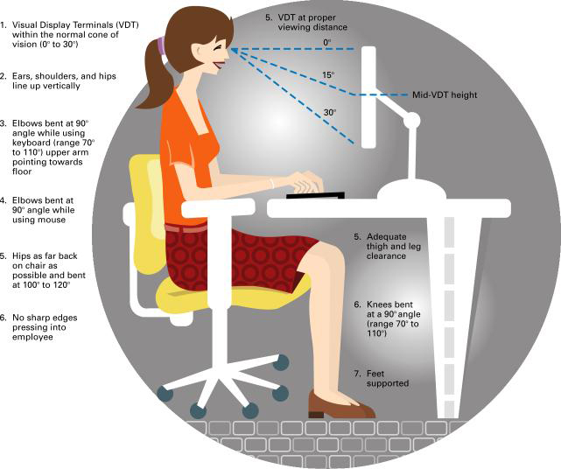
Desktop/Workstation correct set-up

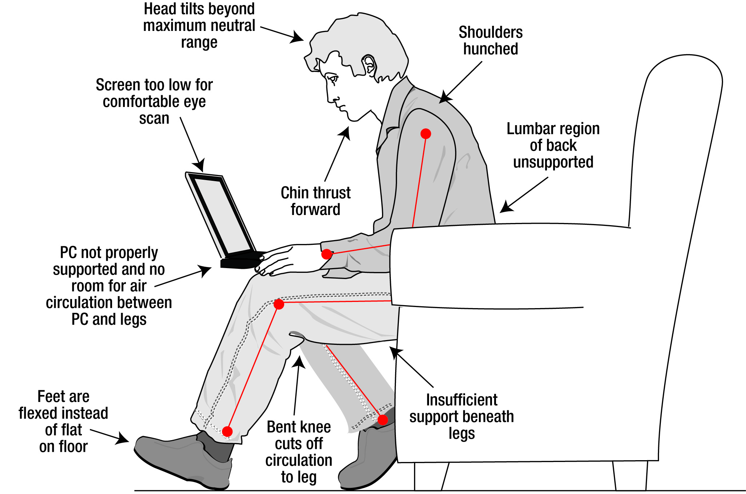
Laptops do’s and Don’ts

Don’t…

Do 