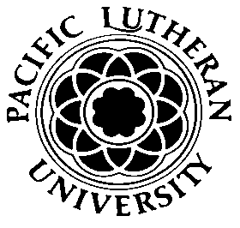 Pacific Lutheran University 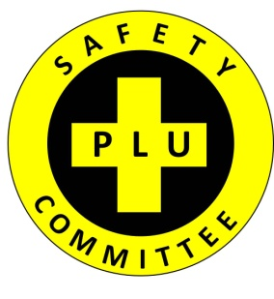
SAFETY COMMITTEE (SC) AGENDA

March 16, 2017
Human Resources (Garfield Station) Conference Room
8:45am - 9:45am

Call to Order
- Approve February 2017 SC Minutes

Call for Additional Agenda Items

Old Business
- SC ideas and participation for table at PLU Benefits Fair: 4/13 – 9:00am to 2:00pm… Tri-fold, Documents, Swag, Participation
- PLU Fire / Evacuation Drill: March 9th … Discussion
  - PLU EBC Participants

New Business
- March Monthly Injury Reports
- Updates on Park Ave crosswalk and Park Ave hedge trimming.

Future Business
Next Meeting: April 20, 2017 @ 8:45am in HR (Garfield Station) Conference Room
Adjourn

