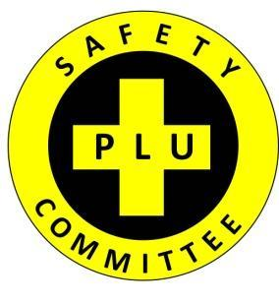

Pacific Lutheran University
Safety Committee (SC) Meeting Minutes

October 19, 2017
Human Resources (Garfield Station) Conference Room
8:45am - 9:45am

Call to Order: 8:45 am
Attending: Josh Girnus, Michael Stasinos, Jason Weaving, Tanner Premo, Hakme Lee, Laura Furhman, Dan Murray, Sue Liden, Aaron Gunther(Co-Chair), Beth Capoun (Co-Chair), Cynthia Wolfer.
Absent: Joe Bell

September meeting minutes: Approved with no changes

OLD BUSINESS:
- Reviewed Spotlight ideas. Cynthia Wolfer emailed a list of safety/health related items to choose from with the idea being that we would get the word out via MAST articles, opportunities for speakers and security workshops, Benefits Fair Tabling, etc. The group was asked to choose 2 and respond by email to Beth Capoun.
- Reviewed the Earthquake Drill: Jason Weaving reported that we need to look into more ADA options for covering themselves and publicizing those.
- A group photo was taken.
- September Injury reports were reviewed.
- PLU Hazardous Material Spill Response Protocol was reviewed and discussed.

NEW BUSINESS:

CALL FOR ADDITIONAL AGENDA ITEMS: None at this time.

FUTURE BUSINESS:
- Next Safety Committee Meeting: November, 16th, 2017 @ 8:45am in HR Conference Room-Garfield Station.

