Welcome to the System
On June 1, 2017 PLU Career Connections launched the new Opportunities Board system. On-campus departments use the Opportunities Board to advertise jobs, collect applications, and report hires to the Student Employment Office.

If you have any questions or difficulties using the system, please contact Tommy Skaggs (skaggsts@plu.edu).

Login:
1) Go To: www.plu.edu/studentemployment

2) Click the “Supervisor Resources” tab on the left

3) Click the big login button

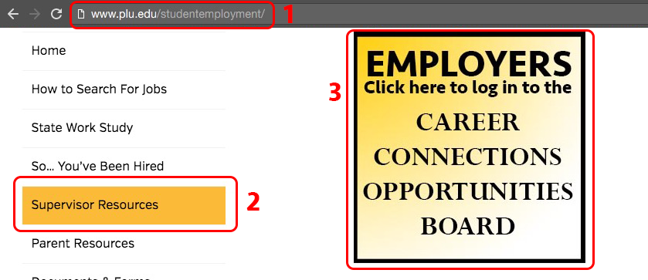

3) The next page will ask for your full PLU e-mail address as your username, and enter your password (the password may be different from your ePass password). If you don’t know your password, click “Forgot Password” and an e-mail will be sent with instructions to reset.

Hire a Student:
1) After logging in, click “Career Outcomes” on the left navigation bar

2) Click “Add New”
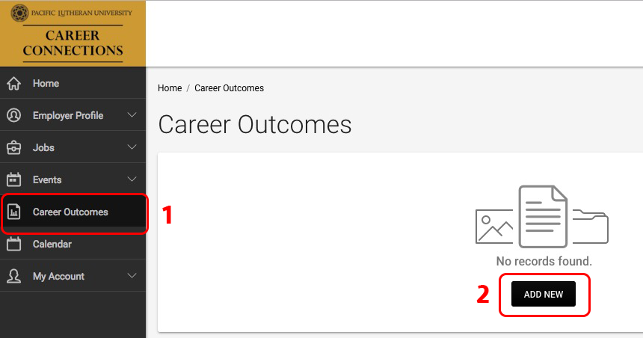

3) Fill Out information on the hire request & Click SUBMIT
The end date can only go thru 5/31/2018
“Notes” field is to alert our office of any exceptions or oddities of the hire
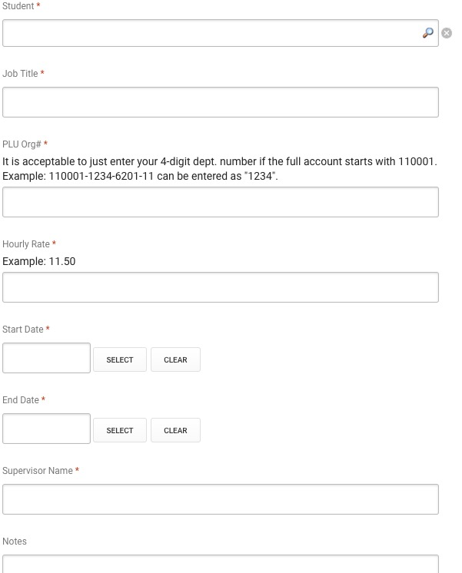

Track Hire Request Status:
1) After submitting a hire request, you can click “Career Outcomes” and see a list of all hires you’ve submitted. Click “Review” to open the record.

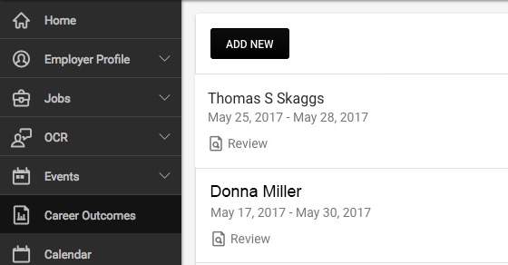

2) Scroll to the bottom of the review page to see the status of the hire, including any notes why there is a delay in processing.

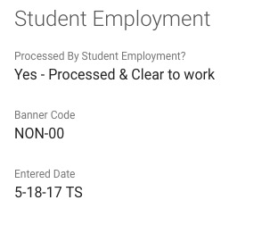

Post a Job:
1) Go to: Jobs > Job Postings then click “Post a Job”

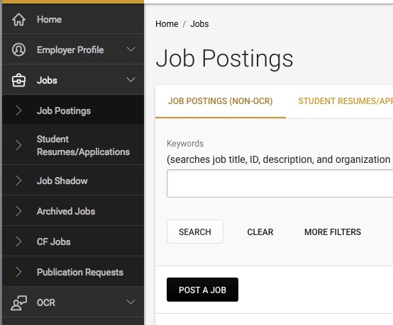

2) If you have a job on file that you want to re-post, use the pull-down box, and select the job you want to copy. This will pull in all the information from that job and let you edit it.

3) Fill out the rest of the fields on this page and click “Submit” or “Save and Finish Later”. Please note the required fields are marked with a “ * “.

Review Applications:
1) Depending how you set up your job, you can receive resumes in different ways. If you are collecting applications via the system, go to Jobs > Student Resumes/Applications. This will pull a list of all applications.

2) Sort by Job or Status. You can give each application a status and a ranking. These are viewable to only you.

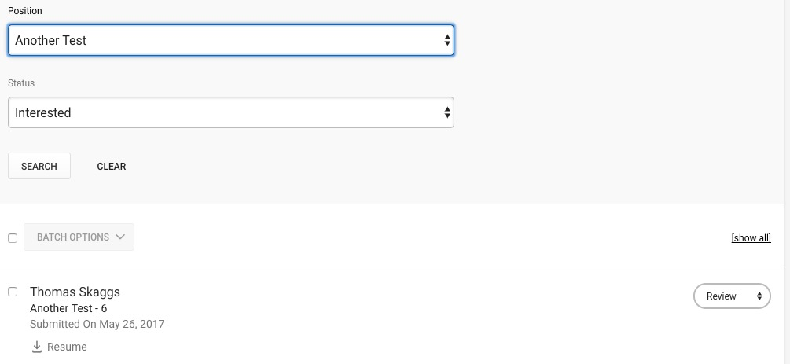

3) Option 2: Go to Jobs > Job Postings, then click the Green button on the far right to review applications.

