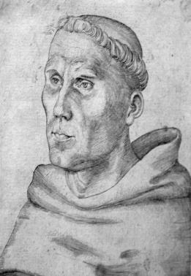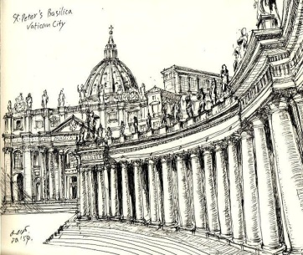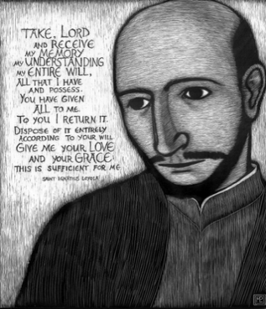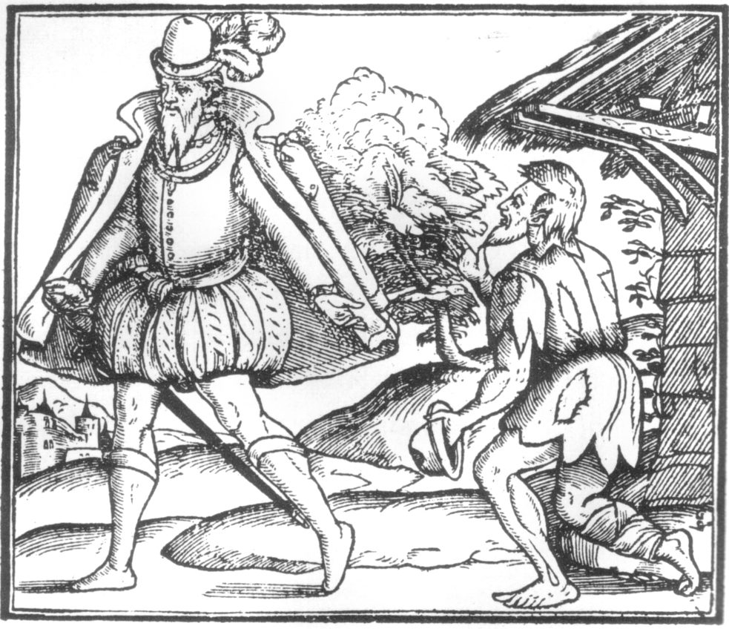
Martin Luther Basilica of St. Peter’s Rome Ignatius Loyola Charity for a homeless person
January Term 2014
Religion 361: Reformation Initiatives for the Poor in Rome
Dr. Samuel Torvend (Department of Religion)
Supplemental Application Form

Please complete this form in Word and email it as an attachment to Dr. Torvend at torvensa@plu.edu. It must be received at the same time you submit the Wang Center study away application to the Wang Center. So, once again: Wang Center application for this course goes to to Wang; this Supplemental Appplication Form, electornically sumbitted, to Dr. Torvend. Yes, some questions here are also asked on the Wang Center form. This form must be completed in full: note carefully what is requested.

Full legal name:

Hometown:

In January 2014, your year at PLU (e.g., junior):

In January 2014, your age:

Your declared major/s and PLU adviser/s:

Your declared minor/s:

Languages you have studied for two (2) or more years and where studied/continue to study them:

Courses taken in college (at PLU or elsewhere: AP/IB and online courses do not count) in: religion, New Testament, theology, church history, ethics, history of western civilization, history of art, history of music, European literature, political science, social work, sociology of religion; include full title of course, when taken (term and year), and name of instructor:

Current cumulative G.P.A. (no guessing; look it up):

Current G.P.A. in the major/s (no guessing; look it up)

Apart from PLU study away courses, if you have travelled outside of the United States in the past five (5) years (Canada and Mexico excluded), please note where you travelled; when you travelled (month/s and year); and why you travelled:

What, if any, previous study away courses have you taken at PLU? List full title of course/s, instructor/s, and year/s taken:

What are the top three sites in Rome you want to visit and why do you want to visit them? (no more than 100 words)

What do you consider the best ways you learn by yourself and in the classroom (if you tell me that you are a “visual learner,” you need to explain it: does it mean you like to look at pictures but have difficulty reading an article?):

Other than books read for PLU classes, what is the last book you read or are reading at the moment (give author and title)? Why are you reading it (no more than 100 words)?

Are you prepared to learn traveler’s Italian before leaving the United States?

Where do you gain your knowledge of world events? How often do you read an online or print newspaper for world events (tell the truth: once a day, once a week, rarely, never)?

In this course, students travel, study, eat, and explore the city and region together. Briefly recount a recent story from your life that expresses the strengths and weaknesses you bring to a community of learners (no more than 200 words):

I understand that if I am selected for this course, I will attend all four (4) class gatherings in Fall 2013 on Sundays, in the later afternoon/early evening: September 22 , October 20, November 17, December 8;
all on-campus classes in the first week of J-Term 2013 (January 2-3, 6-8), and all classes and site visits in Rome. Please note: if you fail to participate in all Fall 2013 pre-travel meetings, you will be dropped from the course. If you fail to participate in all J-term classes (at PLU and in Rome), your final grade for the course, regardless of the quality of work completed, will be dropped one if not two full grades or merit a Fail for the course.

Your name:
Date:

Interview
Please note: you will need to complete an interview with Dr. Torvend, during the week of March 18-22 or April 1-5. Sign-up sheets will be available on his office door, Hauge 207A (currently used by Professor Aimee Hamilton while Dr. Torvend is on sabbatical). Your application materials (Wang application and this Supplemental application) must be submitted prior to the interview. Sign-up sheets will be posted on March 11.

